Salt River Ecosystem Restoration Project

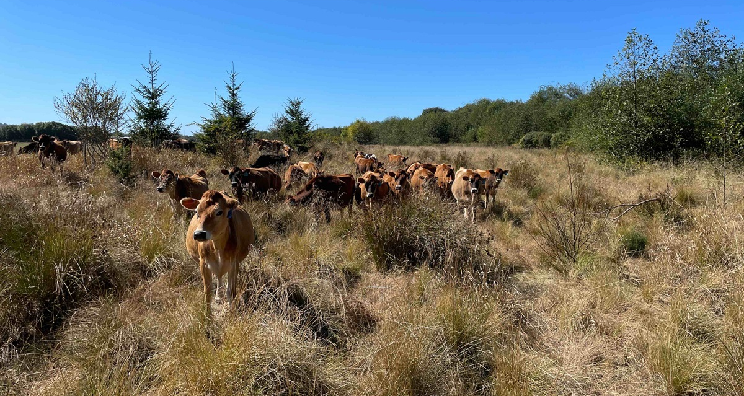
Adaptive Management Plan Monitoring Report 2021
Finalized February 2021

Prepared by the Humboldt County Resource Conservation District 5630 South Broadway
Eureka, CA 95503
707.442-6058 ext. 5
hcrcd@gmail.com
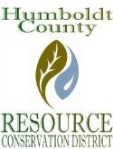

TABLE OF CONTENTS
Executive Summary |  | 3
Summary of Conclusions |  | 6
Introduction |  | 8
Erosion, Sediment Deposition, and Geomorphic Condition Monitoring and Adaptive
Management for Salt River Corridor
 | Cross Sectional and Longitudinal Surveys - Salt River Channel  Corridor | 9
 | Bridges and Culvert Inspections on Salt River Corridor | 11
 | Inspection of Sediment Management Area | 12
Erosion, Sediment Deposition, and Geomorphic Condition Monitoring and Adaptive Management for Riverside Ranch
 | Cross Sectional and Longitudinal Surveys-Riverside Ranch Erosion and Sediment Deposition Surveys | 14
 | Culvert and Tide Gate Inspections on Riverside Ranch | 15
 | Setback Berm Inspection | 17
Water Quality Monitoring and Adaptive Management for the Salt River Corridor and Riverside Ranch
 | Tidal Exchange and Water Quality | 19
Habitat Development, Vegetation and Invasive Species Monitoring, and Adaptive
Management for Salt River Corridor and Riverside Ranch
 | Salmonid and Tidewater Goby Monitoring | 20
 | Aleutian Goose Short-Grass Habitat Monitoring | 21
 | High Marsh Ecotone Vegetation Percent Cover Survey | 24
 | Woody Vegetation Management | 25
 | Weed Abatement | 25
 | Invasive Species Management – Vegetation | 27
 | Invasive Species Management – Pikeminnow | 29
Summary of Adaptive Management Recommendations |  | 30
List of Available Reports |  | 30

EXECUTIVE SUMMARY

The Salt River Ecosystem Restoration Project (Project) has been developed in collaboration with landowners and resource and regulatory agencies for over 30 years. The Humboldt County Resource Conservation District (HCRCD) is spearheading the Project on behalf of multiple private landowners throughout the Salt River watershed. The Salt River watershed is located in Humboldt County, California; approximately 15 miles south of the City of Eureka. The watershed surrounds the City of Ferndale and is bounded to the south by the Wildcat Mountains, to the east and north by the Eel River, and to the west by the Pacific Ocean. The watershed derives its name from the Salt River that historically flowed across the Eel River delta discharging into the Eel River estuary approximately 0.2 miles from the mouth of the Eel River.
The overarching goal of the Project is to restore and improve hydrologic function and fish and wildlife habitat in the Salt River watershed. The Project area includes the main stem of the Salt River, five Salt River tributaries originating in the Wildcat Hills above the town of Ferndale (Coffee, Williams Creek, Francis Creek, Reas Creek, and Smith Creek), and the approximately 400-acre Riverside Ranch, which is contiguous to the Salt River estuary. The California Department of Fish and Wildlife (CDFW) acquired Riverside Ranch in 2012 from Western Rivers Conservancy, who had purchased the property from a willing seller. CDFW is an active partner in the Project. The remainder of the Project area is in private ownership.
The Project intends to restore natural hydrologic processes to a significant portion of the watershed, promoting restoration of ecological processes and functions. The Project is presented in two primary phases to distinguish between the tidal wetland restoration (known as Phase 1) and the riverine corridor restoration work (known as Phase 2). The Project includes work that will be accomplished over several years. Within the two phases, the Project is further broken down in to four primary components, discussed below:

- Upslope erosion control: Work with willing landowners to implement upslope erosion control activities in the upper portions of the Francis, Williams, and Reas Creeks watersheds to reduce the level of sediment input and delivery to the Salt River, thereby improving water quality while reducing sediment deposits in the channel.
- Riverside Ranch tidal marsh restoration: Restore tidal marsh in the lower Salt River. This will also increase the tidal prism exchanged through the lower river, increasing sediment transport potential, increasing scour and promoting hydraulic connectivity with the upper watershed.

- Salt River channel excavation: Excavate and rehabilitate approximately 7.4 miles of the historic Salt River channel to restore hydrologic connectivity within the watershed thereby improving aquatic and riparian habitat, providing fish passage to tributaries, and improve drainage in the delta.

- Adaptive Management: Work with the community and regulatory agencies to implement an environmentally and geomorphically acceptable adaptive maintenance and management program to maintain hydraulic and ecological function in the Project area into the future.

In 2013, restoration of Riverside Ranch (Phase 1 of the Project) restored 330 acres of pasture land back to intertidal wetland habitat, while also preserving approximately 70 acres that is be agriculturally managed to provide short-grass habitat for Aleutian cackling geese and other wetland-associated birds. Three miles of internal slough networks were excavated to create additional habitat for salmonids, tidewater goby, and other fish and aquatic species, and provide areas for the natural recruitment of eelgrass. Two miles of setback berm were constructed to create a boundary between the tidal area and the retained agricultural area, and a gravel road was installed on top of the berm to provide access for monitoring and maintenance. This component of the Project also widened and deepened approximately 2.5 miles of the tidally influenced portion of the Salt River channel, thereby increasing tidal exchange and greatly improving fish passage and fish habitat in the lower Salt River channel.
Phase 2 represents the Salt River “corridor restoration” portion of the larger project. Within Phase 2, 4.5 miles of the Salt River channel and its adjacent floodplain are being constructed and restored. Wetlands and riparian corridors are being re-vegetated with a diverse palette of native plants. Fish passage is being restored to three watershed tributaries – Reas, Francis and Williams Creeks.
Across the years of 2013, 2014, 2015, 2017, 2018, and 2019 a total of 6.2 miles of Salt River channel and floodplain were constructed and re-vegetated. These construction efforts also reconnected two tributaries (Reas and Francis Creek). The 2017 construction season also restored 0.5 miles of the channel and floodplain in Francis Creek. Approximately 1.2 miles of the Phase 2 construction remains to be constructed (Figure 1).
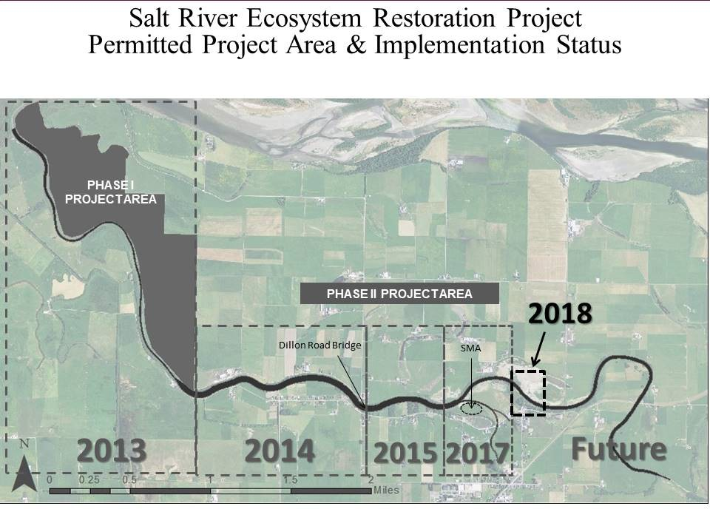
2019
Phase 2A
Upper/2B Lower
Phase 1
Phase 2A Lower
Phase 2A
Middle

Figure 1: Salt River Ecosystem Restoration Construction Timeline as of 2020

Upon completed portions of the Project, monitoring is performed under direction of the Humboldt County Resource Conservation District and complies with requirements generated from Project documents, including the Salt River Ecosystem Restoration Project’s Habitat Mitigation and Monitoring Plan (HMMP) and the Adaptive Management Plan (AMP). This report provides information on data collected for monitoring tasks pertaining to the AMP of the Salt River Ecosystem Restoration Project as follows:

- Phase 1: Year 8 (post construction 2013)
- Phase 2: Year 7, Year 6, Year 4, Year 3, Year 2 (post construction 2014, 2015, 2017, 2018, and 2019 respectively)

As mentioned in the Summary of Conclusions section below, monitoring results demonstrate the Project is performing successfully and largely meeting Project goals.

SUMMARY OF CONCLUSIONS

As detailed in this report, the 2021 monitoring results provide a point of reference on how the restoration activities completed in 2013 (Phase 1), 2014 (Phase 2A Lower), 2015 (Phase 2A Middle), 2017 (Phase 2A Upper/2B Lower), 2018 (Phase 2B Middle), and 2019 (Phase 2B Upper) have responded to the area’s environmental conditions during its formative years after construction. One important environmental input to consider is the previous season’s amount of precipitation. The north coast of California generally experiences precipitation from October to the end of April. This period of time is referred to as a hydrologic year. The amount of the hydrologic year’s precipitation prior to monitoring efforts can significantly affect the findings of a handful of monitoring tasks, such as riparian success and cross- sectional surveys. The 2020/2021 hydrologic year experienced 22.98 inches of precipitation, which is nearly 23 inches below average rain totals. The California Department of Water Resources categorized the 2020/2021 hydrologic year as critically dry.

The following is a brief summary of the findings of the various monitoring efforts under the identified Adaptive Management Plan’s monitoring categories. Please reference individual reports listed at the end of this report for more detailed findings.

Erosion, Sediment Deposition, and Geomorphic Condition Monitoring and Adaptive Management for Salt River Corridor
Previous cross-section surveys on Phase 2 of the Salt River corridor indicate that the Salt River channel is adjusting to the environmental conditions and is trending toward a scour process where the channel bottom elevation is decreasing overall. Tidal exchange and water quality monitoring was required for the first three years after Project construction in tidally influenced regions and was concluded in its entirety across all phases in the Salt River Ecosystem Restoration Project in 2016. Monitoring indicated that water quality parameters achieved ranges appropriate for salmonids at sampling sites and the restored tidal prism reached the predicted extent in the restoration area. Other monitoring under this heading included observing the function of bridges and culverts. For the 2021 monitoring period, existing Dillon Road Bridge and replaced Port Kenyon Road Bridges located within the constructed project footprint were functioning normally as well as one installed private agricultural bridge on Francis Creek and another private agricultural bridge on Salt River. No culverts were installed during the Phase 2 construction, though adjacent culverts are present along the Project footprint at Reas Creek, the Boynton swale, and Bush Street. These were found to be unimpeded. Geomorphic surveys in the Sediment Management Area (SMA) indicate that it captured approximately 8,100 cubic yards over the from winter of 2019 to spring of 2021 hydrologic year.

Erosion, Sediment Deposition, and Geomorphic Condition Monitoring and Adaptive Management for Riverside Ranch
Previous surveys indicate this tidally influenced Phase of the Salt River Ecosystem Restoration Project is highly dynamic with channel capacity fluctuating between years. Past geomorphic surveys revealed deposition and scour in anticipated areas. Additional general visual inspections of the Phase 1 elements include the setback berm, outboard ditches, and tide gates. The setback berm is structurally stable, and no significant changes were observed. The outboard ditches are functioning as designed. All three tide gates are functioning normally with typical leakage and doors have not been observed to have any obstructions.

Water Quality Monitoring and Adaptive Management for the Salt River Corridor and Riverside Ranch
Water quality monitoring was required for the first three years after Project construction in tidally influenced regions. Water quality monitoring was concluded in its entirety across all phases in the Salt River Ecosystem Restoration Project in 2016. Monitoring indicated that water quality parameters achieved ranges appropriate for salmonids at sampling sites and restored tidal prism reached the predicted extent in the restoration area.

Habitat Development, Vegetation and Invasive Species Monitoring, and Adaptive Management for Salt River Corridor and Riverside Ranch
A variety of monitoring and management actions are included under this category, primarily relating to fish and vegetation. A spring and summer fish sampling program has been ongoing since 2014 in constructed phases of the Project. However, survey methods require multiple people to perform fish sampling which violated COVID 19 restriction guidelines in 2021. Therefore, fish sampling was cancelled due to potential health risks, however a separate winter fish sampling event occurred and sampled over 20 juvenile coho in the upper constructed reaches of the river corridor.

The Phase 1 tidal marsh and high marsh ecotone was not scheduled to be monitored in 2021. Phase 2 vegetative monitoring indicated that invasive species are exceeding maximum percent cover allowances. Some minor weed control occurred around the sediment management area. A three acre grazing management pilot project was initiated in the fall of 2021 where non-native and invasive species were trampled and browsed. No woody vegetation maintenance was performed in 2021.

INTRODUCTION

The Salt River Ecosystem Restoration Project (SRERP) took some 30 years to develop and drew upon several studies and assessments completed during that time that examined cultural, biological, geological, aquatic, and vegetative resources as well as tidal influences in the watershed. Project proponents also developed documents to guide implementation, maintenance, and long-term monitoring. Monitoring documents include the Salt River Monitoring Plan, Habitat Mitigation and Monitoring Plan, the Adaptive Management Plan, and other specialized plans to assure the protection of sensitive wildlife habitats, landowner properties, and the hydrologic system itself.

As outlined in the Project’s CEQA and the Adaptive Management Plan documents, a variety of monitoring tasks are required to be conducted to help determine if Project goals and objectives are being achieved, as well as to guide Project management and maintenance. Most of the monitoring tasks are to be completed over a period of ten years, post-implementation. Monitoring was conducted prior to beginning Project implementation to establish baseline data and/or assist in identifying and protecting resources in the Project area. Post-implementation monitoring is being conducted as required by the Project’s various funders, permit requirements, and environmental compliance documents. Many of the individual reports are available from the Humboldt County Resource Conservation District upon request or can be accessed on the website (http://humboldtrcd.org/resources/reports-and-documents/).
This 2021 Adaptive Management Plan Monitoring report is structured and provides findings related to the monitoring requirements in the four identified categories:
- Erosion, Sediment Deposition, and Geomorphic Condition Monitoring and Adaptive Management for Salt River Corridor
- Erosion, Sediment Deposition, and Geomorphic Condition Monitoring and Adaptive Management for Riverside Ranch
- Water Quality Monitoring and Adaptive Management for the Salt River Corridor and Riverside Ranch
- Habitat Development, Vegetation and Invasive Species Monitoring, and Adaptive Management for Salt River Corridor and Riverside Ranch
Within each category is a description that identifies 1) the discrete task called for, 2) the agency requiring the task, 3) the reference document, 4) description of the task, 5) goals and objectives of the tasks, 6) the resulting monitoring report (if applicable), 7) a description of methods, and 8) a results and discussion section.

Erosion, Sediment Deposition, and Geomorphic Condition Monitoring and Adaptive Management for Salt River Corridor
Monitoring Task: Cross Sectional and Longitudinal Surveys-Salt River Channel Corridor –Phase 2 - Erosion and Sediment Deposition Surveys
Agencies/Acts: Coastal Commission, and California Environmental Quality Act (CEQA)
Compliance Documents: Coastal Development Permit- Special Conditions; Salt River Ecosystem Restoration Project Final Environmental Impact Report (FEIR); and Salt River Ecosystem Restoration Project Adaptive Management Plan
Description: Cross-sectional and longitudinal profile surveys are performed across and along the main channel of the Salt River.

Goals:

- Cross-sectional and longitudinal surveys will describe how the channel is remaining consistent with restoration designs, or if areas are aggrading or eroding to the point of intervention.
Report: 2021 Channel Profile Report: Salt River Ecosystem Restoration Project – Phase Two – Year 2021 by Humboldt County Resource Conservation District. January 2022.

Methods: In the previous four years, channel monitoring consisted of performing elevational surveys at four established cross-sections and within the entire constructed 3.5 mile length of the Phase 2 channel by an experienced surveyor or engineer. However, in 2021, due to funding constraints and limited availability and interest by surveyors and engineers, elevational surveys were not performed. As a substitute for these surveys, three Humboldt County Resource Conservation District staff members and landowners walked the entire length of the Phase 2 channel (Figure 2), between the months of April and June, to observe and determine geomorphic conditions in the channel corridor.

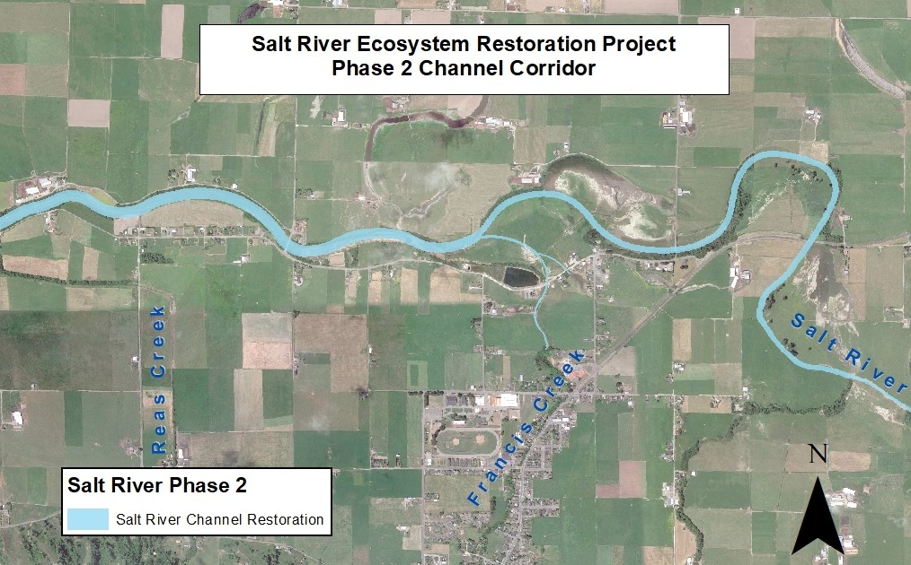
Figure 2: Salt River Phase 2 Channel Corridor. Dashed box delineates the Phase 2 channel that is constructed and surveyed.

Results and Discussion: The observational survey noted water presence throughout the Phase 2 active channel. The active channel from the upstream endpoint to the Francis Creek confluence was dry, as no consistent flow input exists in this upstream area. From the Francis Creek confluence down to Reas Creek, the channel held a shallow amount of water, where tidal influence was seen near the Dillon Road Bridge area.

Established reaches of the Salt River channel (below the confluence of Francis Creek) were seen to have a channel bottom with a naturally formed thalweg, some undercut banks, and vegetated banks. The Salt River channel above the Francis Creek confluence is retaining its constructed channel trapezoidal geometry. Further observations gathered during the entire channel walk did not indicate substantial changes in the channel geometry from previous surveys. No new bank slumping, erosion, scour, or deposition were observed in or along the channel.

Some beds of cattail (Typha sp.) were noted in the channel between the Sediment Management Area and Dillon Road Bridge. This area could slow down water flow, causing deposition within the river channel. It was noted that sections of the channel that had a closed riparian canopy and/or tidal influence did not contain in-channel vegetation. Further vegetation concerns regard large arroyo willow branches growing down and across the channel. Multiple areas within 100 to 400 meters upstream of the Sediment Management Area showed accumulated wood debris amongst the willow branches. However, no apparent channel erosion was observed in the immediate area.

Recommendations: Continue to perform geomorphic surveys in the Salt River channel corridor. Consider removal of in channel cattail beds.

Erosion, Sediment Deposition, and Geomorphic Condition Monitoring and Adaptive Management for Salt River Corridor
Monitoring Task: Bridges and Culvert Inspections on Salt River Corridor

Agencies/Acts: Coastal Commission

Compliance Documents: Coastal Development Permit- Special Conditions; Salt River Ecosystem Restoration Project Adaptive Management Plan
Description: Annual visual inspection of culverts and bridges in the restored Salt River corridor.

Goals:

- All culverts and bridges on the restored Salt River corridor are to remain unobstructed and functional.
Report: N/A.

Methods: All culverts and bridges will be visually inspected upstream and downstream, inlet/outlet, at low and high water flows to determine that these structures are functioning as intended and not being occluded by debris or sediment deposition. Erosion factors will also be noted. Dillion Road, Sousa, Albin, Francis, and Fulmor Bridges span the restored Salt River as of 2019 monitoring season. Existing and adjacent culverts at Reas Creek, Boynton Swale, and Bush Street deliver flows to the Salt River (Figure 3).

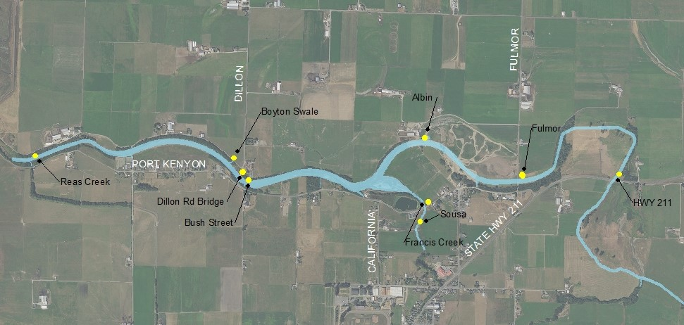

Figure 3: Bridges and Culverts Locations on the Salt River restored corridor

Results and Discussion: Four bridges (Dillion Road, Albin, Sousa, Francis, and Fulmor) span the restored Salt River channel as of the 2019 monitoring period. The Albin, Sousa, and Francis bridges were replaced or constructed as part of the Salt River restoration. All bridges were observed during low flows in April and June 2022 and no debris in the channel or flood plain are racking up on the bridge abutments or installed rock slope protection. Erosion around the footings is not occurring. The Reas Creek, Boynton Swale, and Bush Street culverts have been functioning during high and low flows and appear to be functioning normally. Further follow up on the Bush Street culvert is merited due to dense vegetation obscuring visual observation and possibility that vegetation will eventually impede the opening of the flap gate on the outlet of the culvert.

Recommendation: Continue to monitor bridges and culverts at high and low flows.

Erosion, Sediment Deposition, and Geomorphic Condition Monitoring and Adaptive Management for Salt River Corridor
Monitoring Task: Inspection of the Sediment Management Area

Agencies/Acts: Coastal Commission

Compliance Documents: Coastal Development Permit- Special Conditions; Salt River Ecosystem Restoration Project Adaptive Management Plan
Description: Annual inspection of the sediment management area at the confluence of Francis Creek and the Salt River.

Goals:

- Sustain hydraulic conveyance and ecological function.
- Minimize sediment management maintenance activities.
Report: N/A

Methods: Topographic elevational points were taken across the surface of the sediment management area in June 2021 by the Natural Resources Conservation Service engineer using an RTK unit. Sediments in the sediment management area were dry and solid enough to accommodate access by foot.
Results & Discussion: The active sediment management area at the confluence of Francis Creek and Salt River was surveyed for sediment depositional volume. As of spring of 2021, the sediment management area captured approximately 8,100cy of sediment (Figure 4). The SMA can accommodate up to 15,000cy. No sediment was removed in 2021. It is anticipated that the sediment management area will be excavated (cleaned out) in 2022. In June, during the elevation survey, the sediment management area was devoid of vegetation, however, by August, thick willow establishment occurred (Figure 5). Vegetation was removed by hand at the mouth of the sediment management area and in the Salt River above and below the confluence with Francis Creek.
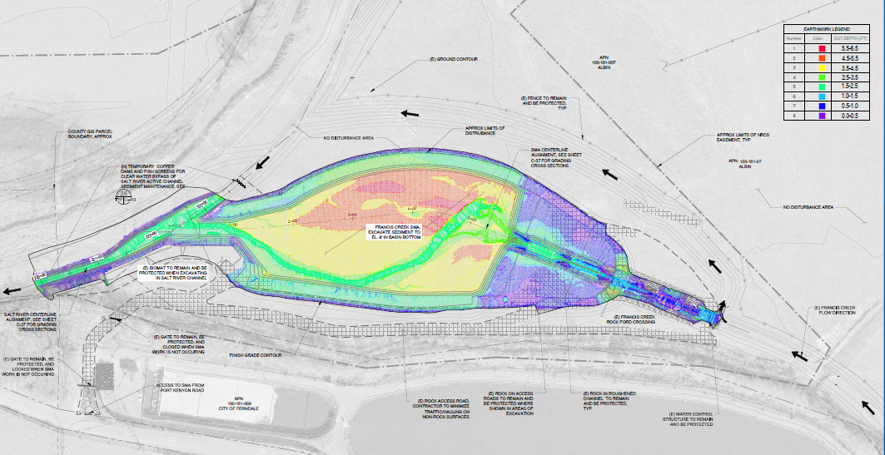
Figure 4. 2021 Geomorphic survey of the sediment management area and estimated captured sediment volume (8,100 cy).

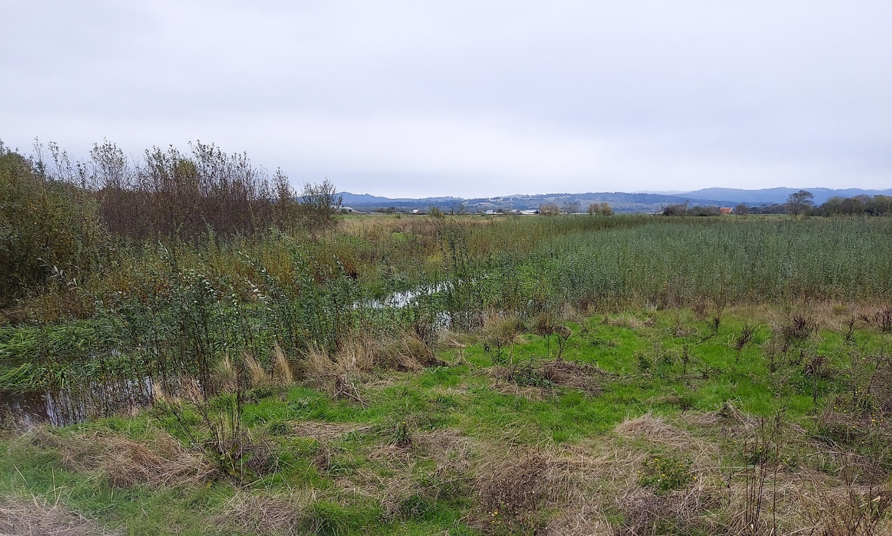
Figure 5. Sediment management area (Fall 2021) near the confluence of Francis Creek and Salt River with establishing willow and sedges

Recommendation: Perform sediment removal activities in 2022 and perform topographic surveys in the sediment management area the following spring.

Erosion, Sediment Deposition, and Geomorphic Condition Monitoring and Adaptive Management for Riverside Ranch
Monitoring Task: Cross Sectional and Longitudinal Surveys- Phase 1 - Riverside Ranch Erosion and Sediment Deposition Surveys

Agencies/Acts: Coastal Commission, and California Environmental Quality Act (CEQA)

Compliance Documents: Coastal Development Permit- Special Conditions; Salt River Ecosystem Restoration Project Final Environmental Impact Report (FEIR); and Salt River Ecosystem Restoration Project Adaptive Management Plan

Description: Cross-sectional and longitudinal profile surveys are performed across and along the main channel Salt River at established sites and on the interior northern and southern slough channels.
Goals:
- Cross-sectional and longitudinal surveys will describe how the channel is remaining consistent with restoration designs or if areas are aggrading or eroding to the point of intervention.
Report: DUE TO COVID AND THE LACK OF A QUALIFIED SURVEYOR A PHASE 1 GEOMORPHIC SURVEY WAS NOT PERFORMED IN 2021.

However, considering the limited winter flow input due to critical drought conditions and the relatively stable geometry of the constructed Salt River channel and interior slough channels over the past eight years, the Humboldt County Resource Conservation District feels confident that no significant changes in channel functionality is occurring that would merit intervention.

Recommendation: Perform geomorphic monitoring in 2022.

Erosion, Sediment Deposition, and Geomorphic Condition Monitoring and Adaptive Management for Riverside Ranch
Monitoring Task: Culvert and Tide Gate Inspections on Riverside Ranch

Agencies/Acts: Coastal Commission

Compliance Documents: Coastal Development Permit- Special Conditions; Salt River Ecosystem Restoration Project Adaptive Management Plan
Description: Annual inspection of tide gates, culverts, and outboard drainage ditch.

Goals:

  - All tide gates and remaining culverts on Riverside Ranch remain unobstructed and operational.
  - The Riverside Ranch outboard ditch will be monitored for flow and erosion impacts and maintained.
Report: N/A. Observational data sheets are available upon request.

Methods: Any culverts or tide gates remaining or installed in Riverside Ranch (Figure 6) as part of the restoration design will be inspected annually and regularly maintained to ensure that they are functioning as designed. Annual reconnaissance of the outboard drainage ditch adjacent to the Riverside Ranch berm will also be conducted to identify areas of impacted flow conveyance and/or erosion and any maintenance recommendations.
HCRCD staff monitored the above items periodically to ensure tide gates and the outboard ditch were working properly to prevent high salinity water from encroaching onto neighboring lands.

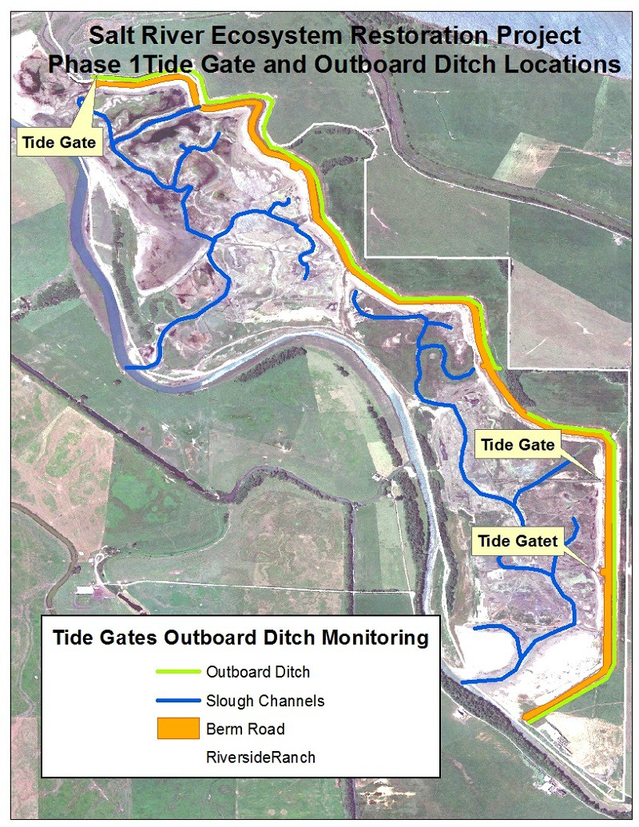

Figure 6: Tide Gates and Outboard Ditch Locations

Results and Discussion: The Phase 1 (Riverside Ranch) project area is monitored for various items, which include the three tide gates and the outboard ditch. The 2021 monitoring was conducted on a periodic basis. No culverts remain on Riverside Ranch; all culverts were removed during construction. The installed tide gates are functioning as expected. No debris has been observed to obstruct the closing or opening of the tide gates. Vegetation in the outboard ditch is managed through grazing activities by the agricultural lessee.

Recommendation: Continue to perform culvert and tide gate inspections on Riverside Ranch.

Erosion, Sediment Deposition, and Geomorphic Condition Monitoring and Adaptive Management for Riverside Ranch
Monitoring Task: Setback Berm Inspection

Agencies/Acts: Coastal Commission, and California Environmental Quality Act (CEQA)
Compliance Documents: Coastal Development Permit- Special Conditions; Salt River Ecosystem Restoration Project Adaptive Management Plan; and Salt River Ecosystem Restoration Project Final Environmental Impact Report (FEIR)
Description: Visual inspections for evidence of erosion and/or cracks after major storm events and high tides.

Goals:

  - Determine if any annual maintenance is needed on the setback berm (berm road).
Report: N/A. Observational data sheets are available upon request.

Methods: Monitoring will consist of qualitative monitoring including visual inspections performed annually and after major storm and high tide events. Monitoring will look for evidence of obvious erosion caused by flooding or erosion resulting from wind generated waves. If significant erosion or signs of potential failure are observed, engineering evaluations will be performed to determine whether any structural repairs are needed.

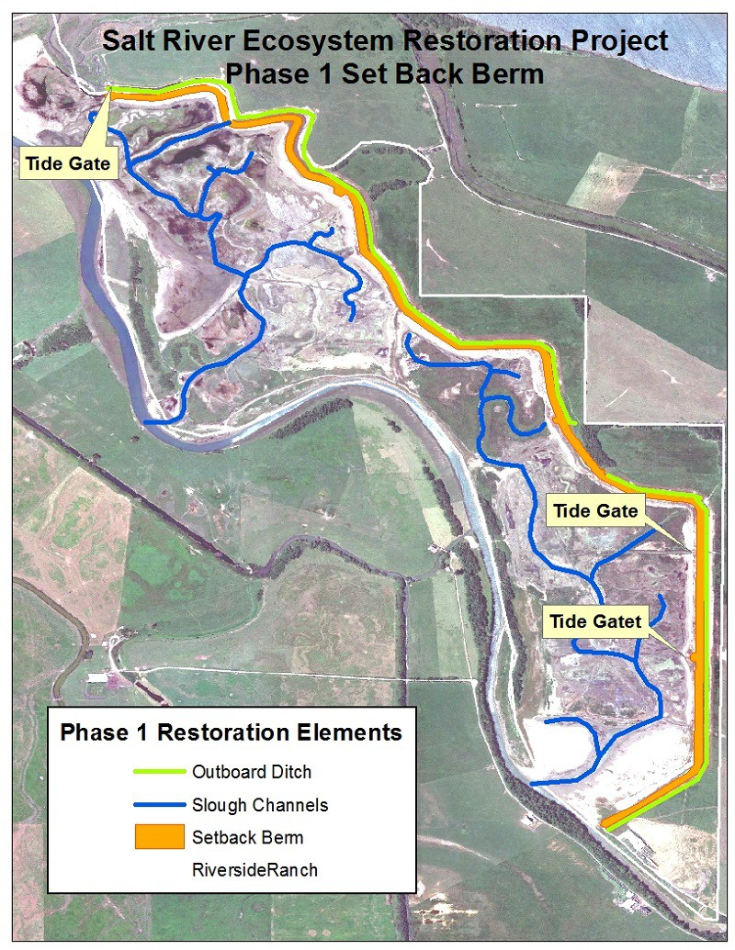

Figure 7: Setback Berm Location

Results and Discussion: Observations of the setback berm and the berm road (Figure 7) were performed periodically in 2021. Minor rills are observed on the estuary side of the berm and have been stable since 2016. Some previous minor erosion caused by wind wave fetch during large winter events is also evident on the northern end of the berm on the estuary side. The road that leads up to the berm from the barn was impacted by a very large Eel River flood event in February 2019, where all gravel and road base material were washed away. California Department of Fish and Wildlife (Riverside Ranch landowner) repaired the impacts to the road.

Further evaluation of the setback berm occurred during 2021 following the initial assessment of potentially modifying the setback berm to alleviate large flood impacts. A topographic survey of the setback berm indicates that the berm has not settled as anticipated and is approximately the same construction height as in 2013 (GHD and Michael Love & Associates 2021). Further extensive hydrologic modeling also indicates that the setback berm and the associated outboard ditch could be modified to increase drainage and alleviate large flood impacts. Further funding will be sought to finalize plans, confirm permitting, and implement modifications.

Recommendation: Continue to perform annual setback berm inspections. Move forward with funding acquisition for berm modification planning, permitting, and implementation.

Water Quality Monitoring and Adaptive Management for the Salt River Corridor and Riverside Ranch
Monitoring Task: Tidal Exchange and Water Quality

Agencies/Acts: Coastal Commission

Compliance Documents: Coastal Development Permit- Special Conditions; Salt River Ecosystem Restoration Project Adaptive Management Plan
*Water level and water quality parameters within the tidally influenced areas of the restored project were required to be conducted for the first three years post- construction. The 2016 monitoring effort marked the end of water level and water quality monitoring. Therefore, water level or water quality monitoring data was not produced for this monitoring report. Additional water quality spot measurements are taken monthly from spring to summer during fish surveys at each monitoring site and indicate appropriate water quality parameters for healthy fish habitat are being met.
Recommendation: Discontinue water quality monitoring as this monitoring task is complete.

Habitat Development, Vegetation and Invasive Species Monitoring, and Adaptive Management for Salt River Corridor and Riverside Ranch
Monitoring Task: Salmonid and Tidewater Goby Monitoring

Agencies/Acts: Coastal Commission

Compliance Documents: Coastal Development Permit- Special Conditions 12, 13; SRERP Habitat Mitigation and Monitoring Plan and the Adaptive Management Plan
Description: Survey for presence of salmonids throughout the project footprint and for tidewater gobies on Phase 1 in the spring through summer months.

Goals:

  - Surveys will show that salmonids and tidewater gobies will utilize the restored Salt River main channel and the tidal slough networks.

Report:

DUE TO COVID 19 RESTRICTIONS MONITORING FOR SALMONID AND TIDEWATER GOBY DID NOT OCCUR

Though spring and summer fish sampling did not occur in 2021, a winter fish sampling evert occurred once in 2021 by Ross Taylor and Associates (2022). In February 2021, 25 juvenile coho were sampled in the Salt River from the confluence of Francis Creek to the upstream end of the constructed project and under the HWY 211 bridge. A majority of the sampled individuals (13) occurred in the rock-grade-control pool at the terminus of the constructed project. Three-spined-stickleback and Sacramento pikeminnow were also sampled during the seining effort.
Given that juvenile coho are present at the end of the constructed project, at the rock grade control, fish passage could be improved by modifying the rock grade control structure to facilitate fish migration towards Williams Creek during high flows.

Recommendations: Reconvene spring-summer salmonid and tidewater goby fish surveys when COVID restrictions are lifted. Consider fish passage improvements to the rock grade control if funding allows.

Habitat Development, Vegetation and Invasive Species Monitoring, and Adaptive Management for Salt River Corridor and Riverside Ranch
Monitoring Task: Aleutian Goose Short-Grass Habitat Monitoring

Agencies/Acts: California Department of Fish and Wildlife (CDFW)

Compliance Documents: Salt River Ecosystem Restoration Project Adaptive Management Plan
Description: Approximately 72 acres of land is retained on Phase 1 (Riverside Ranch) of the Salt River Ecosystem Restoration Project will be agriculturally managed. Agricultural activities will follow CDFW protocols in order to achieve short-grass habitat for migrating flocks of Aleutian cackling geese and other wetland-associated birds.

Goals:

  - Develop a pasture management plan on Phase 1.
  - Annual evaluation of vegetation on Phase 1.
  - Provide short-grass habitat for Aleutian Cackling Geese.

Report: 2020/2021 Aleutian Goose Habitat Evaluation – Riverside Ranch – Salt River ecosystem Restoration Project – Memorandum. Prepared for and by the Humboldt County Resource Conservation District. February 2021.

Methods: To evaluate pasture vegetation for Aleutian Cackling geese habitat, two fields were chosen which provided the highest opportunity for access for geese (Figure 8). The criteria for these areas primarily included open habitat with little or no hedgerows or trees where predators could roost. Grass and other vegetative species were identified in each field. Sward heights were measured at 5 sites across each field and the average was determined. Other observations were considered such as the presence of standing water and density of pasture vegetation.
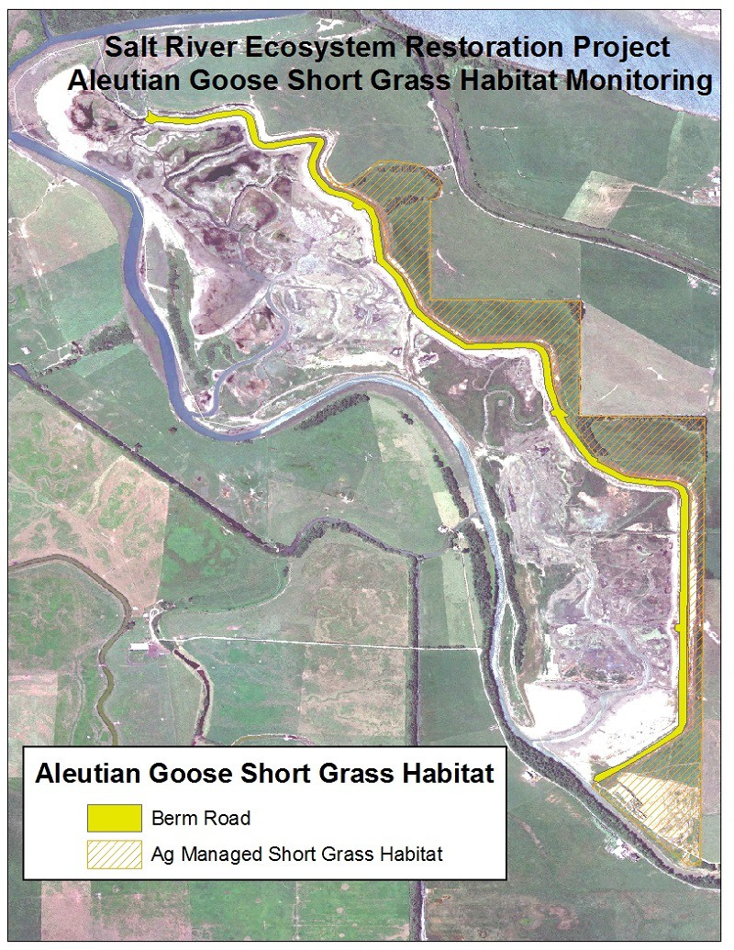
Field 1
Field 2
Field 2
Field 2

Figure 8: Managed Short-Grass Habitat on Phase 1

Results and Discussion:
The 72 acres of agricultural lands (Figure 25) on Riverside Ranch were not managed from 2013 to 2017 due to the State suspending activities on all California Wildlife Management Areas (WMAs). Currently CDFW WMAs are managed by CDFW. In March 2018, CDFW released a Request for Proposals for Permit for Excess Vegetation Disposal on the Salt River Unit of the Eel River Wildlife Area (aka Phase 1/Riverside Ranch). An adjacent dairy producer was awarded a 3-year lease and began management practices in the summer of 2018. CDFW approved the dairy producer’s submitted agricultural management practices for Riverside Ranch which includes rotational grazing of 40 to 200 heifers, depending on grass height, with the option to hay after August 15th to maintain desired grass height. Over two years of agricultural vegetation management has occurred on Riverside Ranch.

It should be noted that geese have not been observed in the Ferndale bottoms area during the 2020/2021 winter. Reduced rainfall may contribute to their absence (as of February 2021, rainfall is 50% of annual winter average). Aleutian and Canada geese were present further north in the Humboldt Bay area. Results for sward height and habitat features are shown in Table 1:

Table 1: Short grass habitat monitoring results for Riverside Ranch – February 2021

FIELD | MONTH | AVERAGE SWARD HEIGHT (inches) | CDFW SWARD HEIGHT CRITERIA (Dec to March) (inches) | VEGETATION AND FEATURES
1 | Feb | 3.6 | 1.5 to 3 | Dominant rye grass, sparse bent grass, and sparse clover. Dense green pasture.  Small ponds of standing water.
2 | Feb | 2.7 | 1.5 to 3 | Sparse bent grass, sparse clover, sparse rye, undesirable wetland species such as juncus.  Frequent bare ground and some small ponds of standing water.

A field visit was performed on February 10, 2021, prior to spring turnout. The two Riverside Ranch fields were sampled in February 2021. The fields were agriculturally managed by using light weight cows (heifers) to graze the pastures. Cows were removed from the pastures in late winter. Grass sward heights were sampled across two fields where biologists determined geese would prefer to forage, as shrub and tree vegetation was minimal or absent. Sward heights were averaged and the values equaled 3.6 inches and 2.7 inches in the respective fields. CDFW recommends that sward height be in the range of 1.5 inches to 3 inches from December to March. The average sward height in field 1 (3.6 inches) slightly exceeds the criteria range. However, field 1 appeared to have productive grass habitat and small water features that are more desirable to geese. Average sward height in field 2 falls within the range of the December-March criteria, however, the vegetation composition is not as desirable (sparse rye grass with wetland species) and frequent bare ground was observed (Figures 9 and 10).

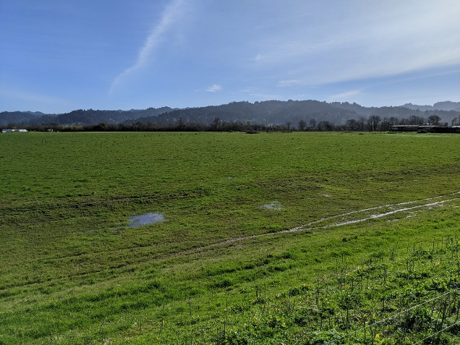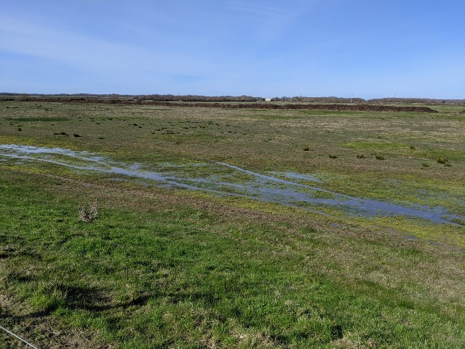
Figures 9 (left) and 10 (right). Field 1 (Figure 9) shows lush pastures with water features. Field 2 (Figure 10) shows sparse pasture with juncus clumps, bare ground, and water features.

Overall, the agricultural fields provide habitat for migrating geese and other species. Previously, the fields laid fallow for five years and is now being agriculturally managed under a lease agreement with CDFW. Short grass habitat appears to be moving in a positive trajectory for Riverside Ranch.

Recommendation: Continue grazing management regime with lessee and annual monitoring efforts.

Habitat Development, Vegetation and Invasive Species Monitoring, and Adaptive Management for Salt River Corridor and Riverside Ranch
Monitoring Task: Salt Marsh, Riparian, and High Marsh Ecotone Vegetation Percent Cover Survey on Riverside Ranch

Agencies/Acts: Coastal Commission

Compliance Documents: Coastal Development Permit- Special Conditions; SRERP Habitat Mitigation and Adaptive Management Plan

Description: Estimate percent cover of vegetation in the salt marsh, riparian, and high marsh ecotone habitats on Riverside Ranch.

Goals: Achieve Native Vegetation Percent Cover of ≥50% in Phase 1 tidal marsh

Report: THE SALT MARSH, RIPARIAN, AND HIGH MARSH ECOTONE VEGETATION PERCENT COVER SURVEYS WERE NOT REQUIRED IN 2021.

Recommendation: Continue to monitor percent cover in the salt marsh, riparian, and high marsh ecotone habitats on Riverside Ranch when monitoring schedule dictates.

Habitat Development, Vegetation and Invasive Species Monitoring, and Adaptive Management for Salt River Corridor and Riverside Ranch
Monitoring Task: Woody Vegetation Management

Agencies/Acts: Coastal Commission

Compliance Documents: Coastal Development Permit- Special Conditions; SRERP Adaptive Management Plan
Description: Perform woody vegetation management (e.g. removal or planting of woody vegetation) to ensure the hydrologic function of the Salt River channel.

Goals:

  - Woody vegetation will be managed consistent with the goal to maintain structure and function of the Salt River corridor.
  - Manage situations that impede channel function.
  - Woody vegetation management cannot contribute to bank or channel erosion.

Report: NO WOODY VEGETATION OCCURRED IN 2021

Recommendation: Continue to disseminate and collect landowner maintenance forms to determine woody vegetation maintenance needs.

Habitat Development, Vegetation and Invasive Species Monitoring, and Adaptive Management for Salt River Corridor and Riverside Ranch
Monitoring Task: Weed Abatement

Agencies/Acts: Coastal Commission

Compliance Documents: Coastal Development Permit- Special Conditions; SRERP Adaptive Management Plan
Description: After 3 years post construction – weed abatement shall be performed using a variety of methods

Goals:

  - Limit colonization of weedy species within the restoration area.
  - Ensure that weedy species do not dominate the restoration area or expand onto adjacent properties.
  - Weedy species do not present a detriment toward maintaining a self-sustaining riparian forest or tidal salt marsh.
Reports:

- 2021 Annual Habitat Monitoring Report - Salt River Ecosystem Restoration Project, Prepared for the Humboldt County Resource Conservation District by J.B. Lovelace & Associates
- Salt River Flash Grazing Assessment 2021. Prepared by the Humboldt County Resource Conservation District. Eureka, CA

Methods: Review vegetation/habitat monitoring report for non-native non-invasive and invasive findings to determine location and percent cover of weed species. Additional observations of invasive vegetation by Humboldt County Resource Conservation staff or other stakeholders will be considered. Weed abatement may include mechanical or manual control by paid staff, contractors, or volunteers. Controlled and limited flash grazing may also be used to control weeds.
Results & Discussion: Staff observation and the vegetation/habitat monitoring effort have found that numerous weedy species exist and are becoming prolific in the restored portions of the project area. Much of the weed species include invasive species such as Spartina densiflora in Phase 1 (tidal esturay), and Agrostis stolonifera (creeping bent grass), Phalaris arundinacea (reed canary grass), and a variety of thistles (Helminthotheca echioides and Cirsium vulgare) in Phase 2 (channel corridor).
No formal project wide weed abatement efforts were made on the restored project footprint. However discrete areas were targeted. The HCRCD staff removed tansy (Tanacetum vulgare) from the 2017 restored reach on Salt River, near the City of Ferndale’s wastewater treatment plant, and around the project’s sediment management area in September of 2021.
A grazing pilot project to control vegetation across approximately three acres in the riparian corridor (at the Salt River Watershed Council Port Kenyon property) was initiated in the fall of 2021. The three acres were divided into two paddocks on the floodplain bench that were grazed sequentially. Approximately 50 head of light weight livestock (1 to 2 year old heifers) had access to a paddock for up to eight days each. Grazing forage in the paddocks was limited, though stalks of invasive reed canary grass were trampled down, revealing planted riparian vegetation. After livestock were removed, the paddocks were assessed for effectiveness of grazing management. The livestock grazed or trampled undesirable vegetation well, however it is recommended that the number of access days to paddocks be reduced as some exploratory browsing on tree trunks occurred.
It has been recommended by re-vegetation experts that much of the reed canary and creeping bent grasses will eventually be controlled when woody riparian species achieve a shaded canopy in the river corridor. Funding proposals are periodically submitted for Spartina densiflora treatment, however no awards were received.
Recommendations: Perform weed vegetation treatment when funding and timing allows. Continue grazing management on the Salt River Watershed Council’s property and reduce number of days livestock have access to paddocks.

Habitat Development, Vegetation and Invasive Species Monitoring, and Adaptive Management for Salt River Corridor and Riverside Ranch
Monitoring Task: Invasive Species Management – Vegetation

Agencies/Acts: Coastal Commission

Compliance Documents: Coastal Development Permit- Special Conditions; SRERP Adaptive Management Plan
Description: Monitor invasive vegetation species during vegetative surveys required by the Habitat Mitigation and Monitoring Plan for the Salt River Ecosystem Restoration Project. Treat identified areas.

Goals:

- Total invasive plant species (dwarf eel grass, Spartina desiflora, and reed canary grass) within sampling areas will not exceed a percent cover of 5%.
Report: 2021 Annual Habitat Monitoring Report - Salt River Ecosystem Restoration Project, Prepared for the Humboldt County Resource Conservation District by J.B. Lovelace & Associates

Methods: Review vegetation/habitat monitoring report for invasive findings to determine location and percent cover of weed species. Additional observations of invasive vegetation by Humboldt County Resource Conservation staff or other stakeholders will be considered. Weed abatement may include mechanical or manual control by paid staff, contractors, or volunteers. Controlled and limited flash grazing may also be used to control weeds.
Results & Discussion: The 2021 Annual Habitat Monitoring Report reveals that all areas of the restored Salt River experiences invasive species presence that exceeds the 5% maximum criteria and recommends that action take place. Much of the invasive species that are present include Spartina densiflora in Phase 1 (tidal esturay), while Agrostis stolonifera (creeping bent grass) and Phalaris arundinacea (reed canary grass) are dominant in Phase 2 (channel corridor).
No formal project wide weed abatement efforts were made on the restored project footprint. However discrete areas were targeted. The HCRCD staff removed tansy (Tanacetum vulgare) from the restored reach on Francis Creek and around the sediment management area in September of 2021.
A grazing pilot project to control vegetation across approximately three acres in the riparian corridor (at the Salt River Watershed Council Port Kenyon property) was initiated in the fall of 2021. The three acres were divided into two paddocks on the floodplain bench that were grazed sequentially. Approximately 50 head of light weight livestock (1 to 2 year old heifers) had access to a paddock for up to eight days each. Grazing forage in the paddocks was limited, though stalks of invasive reed canary grass were trampled down, revealing planted riparian vegetation. After livestock were removed, the paddocks were assessed for effectiveness of grazing management. The livestock grazed or trampled undesirable vegetation well, however it is recommended that the number of access days to paddocks be reduced as some exploratory browsing on tree trunks occurred.
It has been recommended by re-vegetation experts that much of the reed canary and creeping bent grasses will eventually be controlled when woody riparian species achieve a shaded canopy in the river corridor. Funding proposals are periodically submitted for Spartina densiflora treatment, however no awards were received.
Recommendations: Perform vegetative invasive species vegetation treatment when funding and timing allows. Continue grazing management on the Salt River Watershed Council’s property and reduce number of days livestock have access to paddocks.

Habitat Development, Vegetation and Invasive Species Monitoring, and Adaptive Management for Salt River Corridor and Riverside Ranch
Monitoring Task: Invasive Species Management - Pikeminnow

Agencies/Acts: Coastal Commission

Compliance Documents: Coastal Development Permit- Special Conditions; SRERP Adaptive Management Plan
Description: Attempt to control pikeminnow (Ptychocheilus grandis) populations.

Goals:

- Reduce occupation of pikeminnow in newly created habitat.
- Increase occupation by native fish species in newly created habitat.

Report: N/A
Methods: The California Department of Fish and Wildlife, Humboldt State University, and the Humboldt County Resource Conservation District developed a fish monitoring program in early 2014. During the development of this program, participants determined that pikeminnow populations cannot be eradicated or controlled in the Salt River watershed. However, a standard practice was adopted for all pikeminnow encountered during fish monitoring will be humanely euthanized. Additionally, if pikeminnow individuals are longer than 10 inches, those individuals will be measured and the stomach contents examined for evidence of piscivory and findings recorded.
Results & Discussion: Due to COVID restrictions, spring and summer fish sampling did not occur. Therefore, pikeminnow control was not addressed. As fish sampling re-commence in following seasons, fish monitoring efforts will continue to capture and euthanize Sacramento Pikeminnow to reduce their occupation in newly created and restored habitats.
Recommendation: When fish surveys recommence, continue to implement invasive Sacramento pikeminnow control.

SUMMARY OF ADAPTIVE MANAGEMENT RECOMMENDATIONS
- Perform sediment removal activities in 2022 and perform topographic surveys in the sediment management area in spring of 2023 to assess accumulated sediment.

- Move forward with funding acquisition for Riverside Ranch setback berm modification planning, permitting, and implementation.

- Perform non-native and invasive vegetation treatment when funding and timing allows; including instream cattail beds.

- Continue grazing management on the Salt River Watershed Council’s property and reduce number of days livestock have access to paddocks.

- Continue to disseminate and collect landowner maintenance forms to determine channel maintenance needs.

- Continue grazing management regime on Riverside Ranch with lessee and monitoring efforts.

- Consider fish passage improvements to the rock grade control if funding allows.

- Continue to perform annual established monitoring tasks.

LIST OF AVAILABLE REPORTS

H. T. Harvey with Winzler and Kelly. 2012. Salt River Ecosystem Restoration Project Habitat Mitigation and Monitoring Plan. Prepared for the Humboldt County Resource Conservation District. Eureka, California

GHD and Michael Love & Associates. 2021. Riverside Ranch Hydraulic Assesslment. Prepared for the Humbold County Resource Conservation District. Eureka, CA. November 18, 2021.

Humboldt County Resource Conservation District. 2021. 2020/2021 Aleutian Goose Habitat Evaluation – Riverside Ranch – Salt River ecosystem Restoration Project – Memorandum. Prepared for the Humboldt County Resource Conservation District. February 2021.

Humboldt County Resource Conservation District. 2022. 2021 Channel Profile Report: Salt River Ecosystem Restoration Project – Phase Two – Year 2021. Prepared by Humboldt County Resource Conservation District, Doreen Hansen. Eureka, California. January 2022.

Humboldt County Resource Conservation District. 2022. Salt River Flash Grazing Assessment. Prepared by the Humboldt County Resource Conservation District. Eureka, CA

J.B. Lovelace & Associates. 2022. 2021 Annual Habitat Monitoring Report - Salt River Ecosystem Restoration Project, Prepared for the Humboldt County Resource Conservation District.

Ross Taylor and Associates. 2022. Fish Monitoring Samplin in the Salt River – February 4, 2021. Prepared for Prepared for the Humboldt County Resource Conservation District. February 2022.

