Request for Proposals

Post Fire Six Rivers 2022 Restoration Project Phase 1
Date Released: Tuesday, June 10, 2025

CLOSING DATE: Proposals must be received by Thursday, June 26, 2025 by 5 p.m.

PROJECT TITLE: “Post Fire Six Rivers 2022 Restoration Project Phase 1”

CONTACT PERSON: Katrina Henderson, Forest Health Program Manager
Humboldt County Resource Conservation District (HCRCD)
707-496-4849
katrina@hcrcd.org

SCHEDULE:

Release of Request for Proposal (RFP) | Tues, June 10 , 2025
Pre-proposal Meeting (on site) | Wedn., June 18, 2025 at 9:30 am
RFP Questions Due | Thurs., June 19, 2025 by 5pm
HCRCD Responds to Questions | Tue., June 24, 2025 by 5pm
Proposal Due | Thurs., June 26, 2025 by 5pm
Notice of Award | Wedn, July 2, 2025 by 5pm

Proposals for the Post Fire Six Rivers 2022 Restoration Project Phase 1 will be received by the Humboldt County Resource Conservation District (HCRCD) until 5 p.m. on Thursday, June 26, 2025. Submit proposals to:

Katrina Henderson, Program Manager
Humboldt County Resource Conservation District
Humboldt County Agricultural Center
5630 South Broadway
Eureka, CA 95503
katrina@hcrcd.org

Electronic submissions to katrina@hcrcd.org are preferred. Hard copies may be received by US Postal Service or by coordinating hand delivery with Katrina Henderson, Program Manager, at least 48 hours prior.

The HCRCD will conduct a non-mandatory pre-proposal meeting of the Project Areas on June 18, 2025 at 9:30 a.m. The meeting will commence at the Bigfoot Museum parking lot at 38949 Hwy. 299 in Willow Creek, CA. Please contact the HCRCD for detailed directions. All interested parties are required to R.S.V.P to Program Manager, Katrina Henderson by email at katrina@hcrcd.org. Final questions need to be submitted no later than June 19, 2025 at 5:00 p.m. in email format to katrina@hcrcd.org. Responses from the pre-proposal meeting to all questions submitted via email will be posted as an addendum to the RFP at the HCRCD website (www.humboldtrcd.org) no later than June 24, 2025 at 5:00 p.m.

All interested firms are invited to submit a proposal in accordance with the terms and conditions stated in the Request for Proposals which can be accessed at the HCRCD website (www.humboldtrcd.org).

BACKGROUND

The HCRCD is seeking proposals from qualified and experienced contractors to provide all labor, materials and equipment necessary to carry out the Post Fire Six Rivers 2022 Restoration Project Phase 1.

The HCRCD intends to make an award using the evaluation criteria listed in the specification to determine the proposal with the best value for the HCRCD. This type of fuel reduction work is not currently considered a public works project under Labor Code 1720; therefore, his project is not considered a Public Works project and not subject to prevailing wage requirements.

The respondents are expected to identify the cost to complete the work and provide unit costs as identified in the Schedule of Items/ Proposal Form (Exhibit B) for each item specified. The actual quantities required may fluctuate up or down, the unit prices proposed by each respondent will remain firm and will not be negotiated. All unit prices shall include all necessary overhead and profit. Items not listed in the schedule of values such as preparation and submittal of necessary permits, profit, etc. shall be distributed throughout the respondent’s unit process for the items listed. The respondent must submit pricing as requested in the RFP.

The respondents are advised that the maps, statement of work, and specifications included in this solicitation are intended to be the basis for performance of the Project and for the purpose of establishing a cost proposal for completing the mitigation. The maps, statement of work and specifications were prepared by the HCRCD and convey the general overall scope and nature of the Project, including descriptions of the environmental mitigation and protection requirements.

PROJECT SUMMARY

The Project will restore post fire habitat on approximately 30 acres total within one project area in Willow Creek to remove hazardous vegetation. This project area is filed under CALFIRE Emergency Notice and Oak Woodland Exemption. Commercial harvest activities will be a component of this project. Trees to be removed will be sample marked with spray paint or other methods by a Registered Professional Forester (RPF) in at least 10% of each forest type within the project area. An LTO-A license is required to complete this work and the LTO-A license will be recorded on the CALFIRE exemption. Mechanical and manual treatments may be used. At the LTO-A’s discretion, manual crews may be hired as subcontractors under the LTO-A. The objectives of this Project are to:
- Significantly reduce hazardous vegetation from within the Six Rivers 2022 wildfire footprint and adjacent areas.
- Increase overall forest health and resilience within local communities.
The HCRCD contracted James L. Able Forestry Consultants, Inc. to provide RPF services in association with this project. HCRCD and the LANDOWNER have a landowner agreement binding them to the terms and conditions of the project. LANDOWNERs will be given CONTRACTOR’S contact information and vice versa. The landowners relinquished all ownership of affected commercial forest products created during the project. HCRCD owns the forest products during the time period of the project.

The timeline for the project is approximately listed below. CALFIRE exemption permits are valid for one year after filing and all project activities must be completed during that time.
July 2025: RPF to submit exemption paperwork and show log buyers the wood.
July 2025: Begin operations.
August- September 2025: Complete operations.
June 2026: project completion date.
This plan is subject to change depending on weather.

PDF maps will be provided to the CONTRACTOR. All cultural and biological resource surveys will be completed prior to project implementation.

PROJECT AREA

The Post Fire- Six Rivers 2022 Restoration Project Phase 1 is located near Willow Creek in Humboldt County, California in SEC 21, T7N; R5E; HB&M. The project area is a mix of dense resprouting vegetation and standing dead trees. The project occurs in the footprint of the Six Rivers 2022 wildfire and adjacent areas and is funded by the USDA Forest Service. The USDA Forest Service is an equal opportunity provider.

The unit has been defined as follows:
- Unit 1: 30.4 acres
- See Figure 1-4 for details on landings, infrastructure and road access.
- Emergency Notice CALFIRE and Oak Woodland Management Exemption will be used.
- Mortality from the wildfire was moderate to severe.
- The unit consists of the removal of shrubs, standing dead trees, and re-sprouting vegetation.
- Heavy vegetation removal may occur by mechanical treatment of standing forest structure of any size tree onsite that is deemed a hazard. Conifer leave trees are identified within the units with orange paint on the tree bole at or above DBH and the stump mark.
- Remove 80% of the brush vegetation down to 1” in diameter to reduce ladder fuels.
- Slash and debris will be disposed of by piling and burning, lop and scattering, mastication or chipping. Minimum of 90% of the slash and debris shall be treated per acre.
- Merchantable logs will be commercialized and sent to a local mill or firewood operation.

SCOPE OF WORK
The Contractor is required to comply with all terms and requirements as defined in the Request for Proposals. The scope of work for this project includes the activities necessary to reduce hazardous fuels. This may include a variety of activities such as: clearing of standing and downed dead trees and debris, yarding of most logs and debris to piles or other locations where they will be burned or otherwise disposed of and yarding of designated trees to designated landings. All costs should be proposed on a treatment per acre basis.

There may also be downed logs that are still merchantable and will require treatment. Activities associated with these treatments include but are not limited to: manufacturing commercial sawlogs, manufacturing firewood logs, loading logs onto transportation, contracting transportation, documenting and reporting transportation of material to the HCRCD and RPF. In addition to the treatment of slash and cutting of trees, fuels reduction activities will also require removal of ladder fuels, pruning of live trees, rehabilitation of disturbed areas to comply with state standards and laws such as installation of erosion control measures including but not limited to water bars, rolling dips, straw mulch, waddles, slash packing, etc. The removal of stumps is not permitted.

Hazardous Fuels Treatment
CONTRACTOR may utilize manual and mechanical treatments with a variety of methods or equipment. CONTRACTOR can choose what equipment is used at each project site to maximize efficiency and reduce costs as allowed by the CALFIRE Exemptions and California Forest Practice Rules. CONTRACTOR may choose to subcontract work for parts of the project, such as subcontracting a manual fuels crew. CONTRACTOR shall furnish fuel and all supplies for equipment maintenance. Equipment shall be cleaned before entering the Project Area to prevent spread of noxious weeds and pathogens. Equipment should be free of leaks, in good operating condition, and have spark arresting equipment or a supercharger.

CONTRACTOR will follow the prescription created by Registered Professional Forester. Trees to be cut or leave will be marked with spray paint or other methods and are not-negotiable. Some treatments may be described by species and size to be cut such as with small diameter and non merchantable trees. If any marked tree is not feasible to leave or cut, this should be discussed and approved by the RPF and HCRCD representatives.

Harvesting of live, dead, diseased or dying trees may occur of all size classes. In areas where the existing canopy is too open to suppress re-growth of shrubs, established seedlings and saplings of tree species will be retained. Seedlings and saplings will be selected based on species and vigor and located where openings in the canopy exist. Extreme care must be exercised by the contractor to not damage residual trees during operations. Failure to protect the residual trees may result in termination or revision of contract. All material will be processed.
Contractor should provide rates for the following activities at a per acre basis:

- Tree Felling and Yarding
This includes cutting of live standing trees, hazard trees, fallen dead trees, brush etc. so as to comply with the applicable CALFIRE exemptions. All trees to be cut or leave will be marked with spray paint or other methods and are not-negotiable. Some treatments may be described by species and size to be cut such as with small diameter and non merchantable trees. Specifications for yarding of logs to landings will be provided to the Contractor at the pre-operations meeting. This also includes yarding of large woody material 4” and larger in diameter to designated landing locations. Yarding may be accomplished by ground-based tractor methods on slopes less than 50%, or with cable/winching/manual-based methods on steeper terrain. Ground based mechanical operations may be conducted on stable roads that have adjacent slopes over 50% as directed by the RPF and HCRCD representatives. Manufacturing specifications of saw or firewood logs will be discussed at the pre-operations meeting as well.

Landowner has requested that two cords of firewood and all wood chips be left for their personal use. In those instances, firewood quality limbs and logs larger than six inches diameter will be safely stacked at designated landings and will be kept separate from commercial logs. Logs will be left no longer than 16 feet. Wood chips will be left in piles.

- Slash Treatment
This includes treatment of slash existing on the project from blow down and previous activities as well as treatment of slash generated from cutting of trees. This includes but is not limited to chipping, mastication, manual lopping and scattering, pile building, pile burning, and hauling off site. Slash depth, including chip piles, is limited to 18” deep on average over the project area. Vegetative debris from mastication shall lie flat on the ground. Treated vegetation shall not be left in excessive quantities around residual healthy trees.

All permits for pile burning are the responsibility of the Contractor. Piles shall be neat, compact and sufficiently free of dirt to allow consumption of the piled debris when burned. A portion of the pile shall be covered with paper to enhance ignition.

- Loading and Transportation
This involves the loading of large woody debris in the form of logs onto transportation. Landings are designated by RPF at pre-operations meeting but may be located in other locations with consultation of RPF or HCRCD representatives. Loading can occur anywhere that saturated soil conditions do not exist. Log size and quantity will be determined with the CONTRACTOR. Loading and transportation are listed at a per hour base to reflect the unknown amount of material. Longer lengths will be prioritized for log truck transport. Firewood logs will be left in lengths so as to fit into the transportation method. Shorter lengths for dump truck and longer lengths for longer dump trailers or log trucks. Destinations for firewood logs is in Arcata and Samoa. New destinations may be added during the course of operations and travel time adjusted and paid accordingly. All trucking and loading fees will be paid for by HCRCD per an hourly basis.

All state laws and regulations such as the Forest Practice Rules, Fire Protection, Water Quality and Wildlife protections, as well as HCRCD stated BMPs shall be followed during conducting of operations on this project. This also includes all road maintenance such as water barring, erosion control installation, grading and repairing of roads that are excessively damaged by operations, and watering of roads where necessary.

HCRCD Inspections

HCRCD contracted Registered Professional Foresters (RPF) through James L. James Forestry Consultants, Inc. to inspect all work and ensure that the services are acceptable. The inspection does not relieve the CONTRACTOR of the responsibility for maintaining quality control.
Inspections and a submitted report from RPFs will be required prior to HCRCD accepting invoices from the CONTRACTOR. Invoices will be accepted monthly or quarterly. Inspections for payment will be made on completed items only. Please note that payments of the contractor’s invoices are subject to the reimbursement schedule dictated by the funding source and may be delayed up to 90 – 120 days from HCRCD’s receipt of contractor’s invoice and submission of reimbursement request. HCRCD will withhold up to 5% percent of the invoice amount until contract completion.

Identification of Protected Species or Other Critical Resources

With all environmentally sensitive areas, identification and avoidance during project implementation is important. Should any sensitive resources be found during project implementation, the area should be avoided until the appropriate agencies and HCRCD staff review the situation.

CONTRACTOR shall comply with all applicable federal, state and local laws, regulations and policies governing the funds and scope under this agreement.

Winter Operating Plan
The project may be conducted during the winter period. The Winter Operating Plan applies to the period November 1 to April 1.
  - Heavy equipment shall not be used under saturated soil conditions as directed by the supervising RPF. Saturated soil conditions may be indicated by potential for significant sediment discharge or equipment inoperability under its own power (see Forest Practice Regulations 895.1).

Best Management Practices (Standard Operating Procedures)

The project is designed to avoid or minimize impacts to cultural and biological resources and Best Management Practices (BMPs) will be implemented to avoid any erosion during project activities. CONTRACTOR will comply with CALFIRE Exemption standards and in addition, the standards listed below.

General:
- Contractor shall be responsible for ensuring protection of structures, fences, power lines and other utilities, including underground water lines, power lines, communication lines, septic systems and drainage structures. The RPF will provide information on the location of infrastructure prior to operations.
- Burn piles will be located outside of any Watercourse Lake and Protection Zone (WLPZ). Burn piles will be located at least 25 feet from the dripline of any residual trees.

Noise:
- Hours of operation will be limited to the hours of 5 a.m. to 6 p.m. to minimize the potential for noise impacts on residences near and within the project area.
- All equipment used in site preparation will meet or exceed State standards for noise control.

Fire Prevention:
- HCRCD will coordinate with the CONTRACTOR to stop or reduce work hours during periods of increased predicted fire risk based on local fuel and weather data. CONTRACTOR should anticipate work stoppage to occur during Red Flag Warnings or days with Adjective Ratings of Very High or Above.

Cultural Resources:
- Surveys were conducted to determine if cultural resources are located on participating parcels. If present, survey results are confidential. All known cultural resources will be flagged or otherwise indicated in the field. A monitor may be necessary during operations and the monitor will be designated by HCRCD.
- If previously unknown cultural resources are discovered during operations, all work in the area shall cease and the RPF and HCRCD staff shall be notified. Any cultural sites discovered during operations will be flagged for avoidance.

Traffic:
- If necessary, warning signs will be posted in work areas to alert oncoming traffic to the safety hazards associated with the operation. Signs are the responsibility of the Contractor.

GENERAL

- It is not the intent of the specifications to cover each and every detail. Any problems that may arise must be promptly reported to the HCRCD or Partners and will be subject to the decision of the HCRCD. The CONTRACTOR is expected to carefully examine the size and scope of the proposed work prior to submitting its proposal. The CONTRACTOR certifies it has checked carefully all the quantities, specifications, maps and figures, and understands that the HCRCD nor Partners will not be responsible for any errors or omissions on the part of the CONTRACTOR in compiling and submitting this proposal.

- The CONTRACTOR agrees that they will provide the materials and/or perform the work herein under the terms and conditions set forth in the awarded contract; and shall furnish and be responsible for all the labor, materials, tools, equipment, transportation, insurance, notifications, licenses, permits, and all other services and facilities necessary, including all incidental work and appurtenances as may be reasonably implied and as described in the specifications and other Contract documents. All costs incidental to these requirements will not be paid for separately but shall be included in the work, including testing, if needed. CONTRACTOR shall be responsible to pay all costs for permits, licenses, fees and insurance which may be required to perform the work required.

- CONTRACTOR will obtain and maintain in full force and effect throughout the term of this Project, and thereafter as to matters occurring during the term of this Project, the insurance coverage as specified in Exhibit C. Agreement Template.

- Any portion or aspect of the property, including but not limited to roads, trails, gates, fences, culverts and/or drainage structures, or signs or other improvements damaged by CONTRACTOR will be repaired to a like or better condition at the end of the project as that found prior to the start of work. Repairs may include repairing or replacing drainage control features. Upon notice from HCRCD, significant damage to existing roads, trails or other improvements, caused by CONTRACTOR, must be repaired by CONTRACTOR at CONTRACTOR’s expense within ten (10) working days of the notification by the HCRCD.

- CONTRACTOR will obtain any and all permits required for transporting and hauling activities on state and county roads. Haul routes must be planned, prior to proposing, observing load limits on bridges or roadways, existing roadway conditions, and Federal, State and local governmental regulations regarding truck traffic and truck routes. The CONTRACTOR shall comply with all legal load restrictions in hauling of materials on public roads. Permits as required must be obtained by the CONTRACTOR at its cost. Permits will not relieve the CONTRACTOR of liability for damage which may result from moving equipment. The operation of equipment of such weight or so loaded as to cause damage to roadways or to structures or to any type of construction will not be permitted. Hauling of materials over unpaved roads shall be only as directed by the HCRCD. The CONTRACTOR shall be responsible for all damage done by his hauling equipment.

- The work site should be left in a safe manner at the end of every workday, and the CONTRACTOR will take all reasonable precautions to avoid injury to the public.

- Before daily acceptance, all areas occupied by the CONTRACTOR in connection with the work shall be cleaned of all CONTRACTOR garbage, excess materials, temporary structures, and equipment, and all parts of the work area shall be left in a neat and presentable condition.

- Coordinate all work as necessary to complete the project, avoid damages to utilities and maintain utility service with each affected utility company.

9. Current federal Internal Revenue Service mileage rate will be accepted. In 2025 the rate is $0.70/mile.

Proposal Submission Guidelines

Release of Request for Proposal (RFP) | Tues., June 10, 2025
Pre-proposal Meeting (on site) | Wedn., June 18, 2025 at 9:30 am
RFP Questions Due | Thurs., June 19, 2025 by 5pm
HCRCD Responds to Questions | Tue., June 24, 2025 by 5pm
Proposal Due | Thurs., June 26, 2025 by 5pm
Notice of Award | Wedn., July 2, 2025 by 5pm

The schedule is tentative and may be subject to change by the HCRCD.

Award of Contract
The HCRCD may reject any and all proposals and re-issue this RFP. The HCRCD may waive any minor irregularities or immaterial defects in a proposal. The HCRCD reserves the right to request additional written or oral information from CONTRACTOR to obtain clarification on their proposals. All proposals become the property of the HCRCD and become a public record. All costs associated with development of the proposal in response to the RFP shall be the sole responsibility of the CONTRACTOR and shall not be charged in any manner to the HCRCD.

Selection of the contract will be made within two weeks after the proposal due date to the proposal that meets the required qualifications, scope of work and selection criteria.

Proposal Submission
The Proposal must be received no later than 5:00 p. m. on June 26, 2025 by electronic submission to Katrina Henderson, Program Manager (katrina@hcrcd.org) (preferred) or hard copy via US Postal Service to the HCRCD office located in the Humboldt County Agricultural Center at 5630 South Broadway, Eureka, CA 95503. It is recommended to coordinate hand delivery of hard copies of the Proposal with Katrina Henderson at least 48 hours prior. Faxed or late Proposal will not be accepted. It is the responsibility of the CONTRACTOR to assure that the Proposal is received prior to the deadline date and time. Proposals received after the submission deadline will not be accepted and will be returned unopened.

Any changes to this RFP are invalid unless specifically modified by the HCRCD and issued as a separate addendum document. Should there be any question as to changes to the content of this document, the HCRCD’s copy shall prevail.

Proposal Format
Please use the Schedule of Items/ Proposal Form provided as Exhibit B to submit CONTRACTOR’s Proposal. A word document will also be included for download on the HCRCD’s website. All sections must be filled out unless noted as “optional” in Exhibit B. Proposals that do not furnish information organized according to the Schedule of Items/ Proposal Form or do not include the content specified in this RFP may be rejected as non-responsive. Responses may be handwritten or typed, and additional pages may be included to convey required information.

CONTRACTORs shall describe the methodology to be used to accomplish the tasks required for the scope of services. The HCRCD relies on the professional expertise and competence of the selected contractor and expects the contractor to be knowledgeable of the specific services identified in the scope of work and to include in its proposal all tasks required to implement the scope of services. The Schedule of Items/ Proposal Form includes the following sections:

Project Understanding and Approach: Provide an overview of your understanding of the services to be provided and your approach to the work, including but not limited to a) specification of equipment to be utilized (include make and model), b) staffing requirement expectations, c) proposed schedule for accomplishing the work, and d) any other items the firm feels necessary to demonstrate the firm’s proposed strategy to complete the project.

Experience and Qualifications: Provide a general description of the firm’s experience and qualifications related fuels reduction work, highlighting previous work conducted for public agencies. Please include any anticipated subcontractors. Provide concise resumes of key staff and subcontractors indicating the names and roles of staff and subcontractors and their experience. Provide two (2) professional references who can attest to CONTRACTOR’s qualifications and experience.

Cost Proposal: The Cost Proposal will be submitted based on the Schedule of Items. Estimated quantities are based upon the best available information at the time of advertisement of the RFP. The actual acreages treated will be the basis of payment. The unit prices will remain firm and will not be negotiated. In case of discrepancy between unit prices and totals, unit prices will prevail.

Evaluation Process
HCRCD staff will evaluate all proposals received for completeness and the CONTRACTOR’s ability to meet all specifications as outlined in this RFP. The following evaluation criteria and weight of importance will be used in evaluating and selecting a contractor. Cost proposal criteria points will be awarded on a relative scale as described below.

Evaluation Criteria | Points
Budget
Reasonable contractor rate and expenses | 40
Attendance at pre-bid walk | 5
Prior Experience and Past Performance
Demonstrated competence in the desired qualifications and experience outlined in this RFP | 45
Thoroughness, quality, and responsiveness of submission | 5
Quality and relevance of references | 5

QUESTIONS/ ADDENDA
Any questions about this RFP shall be submitted in writing to the following email address: katrina@hcrcd.org. To be considered, questions must be received by the HCRCD no later than 5:00 p.m. on June 19, 2025. The HCRCD may, if deemed necessary, respond to questions by issuance of formal addenda, interpreting or clarifying the requirements of this RFP. Any addenda processed shall be made part of this RFP request and binding upon each CONTRACTOR. All addenda will be posted on the HCRCD’s website. Each bidder is solely responsible for obtaining all addenda posted on the HCRCD’s website. The HCRCD may also direct attention to specific provisions of the RFP which cover the subject of the inquiry.

ATTACHMENTS:
EXHIBIT A – Project Area Maps
EXHIBIT B – Proposal Template & Schedule of Items
EXHIBIT C – Agreement Template

EXHIBIT A – Project Area Maps

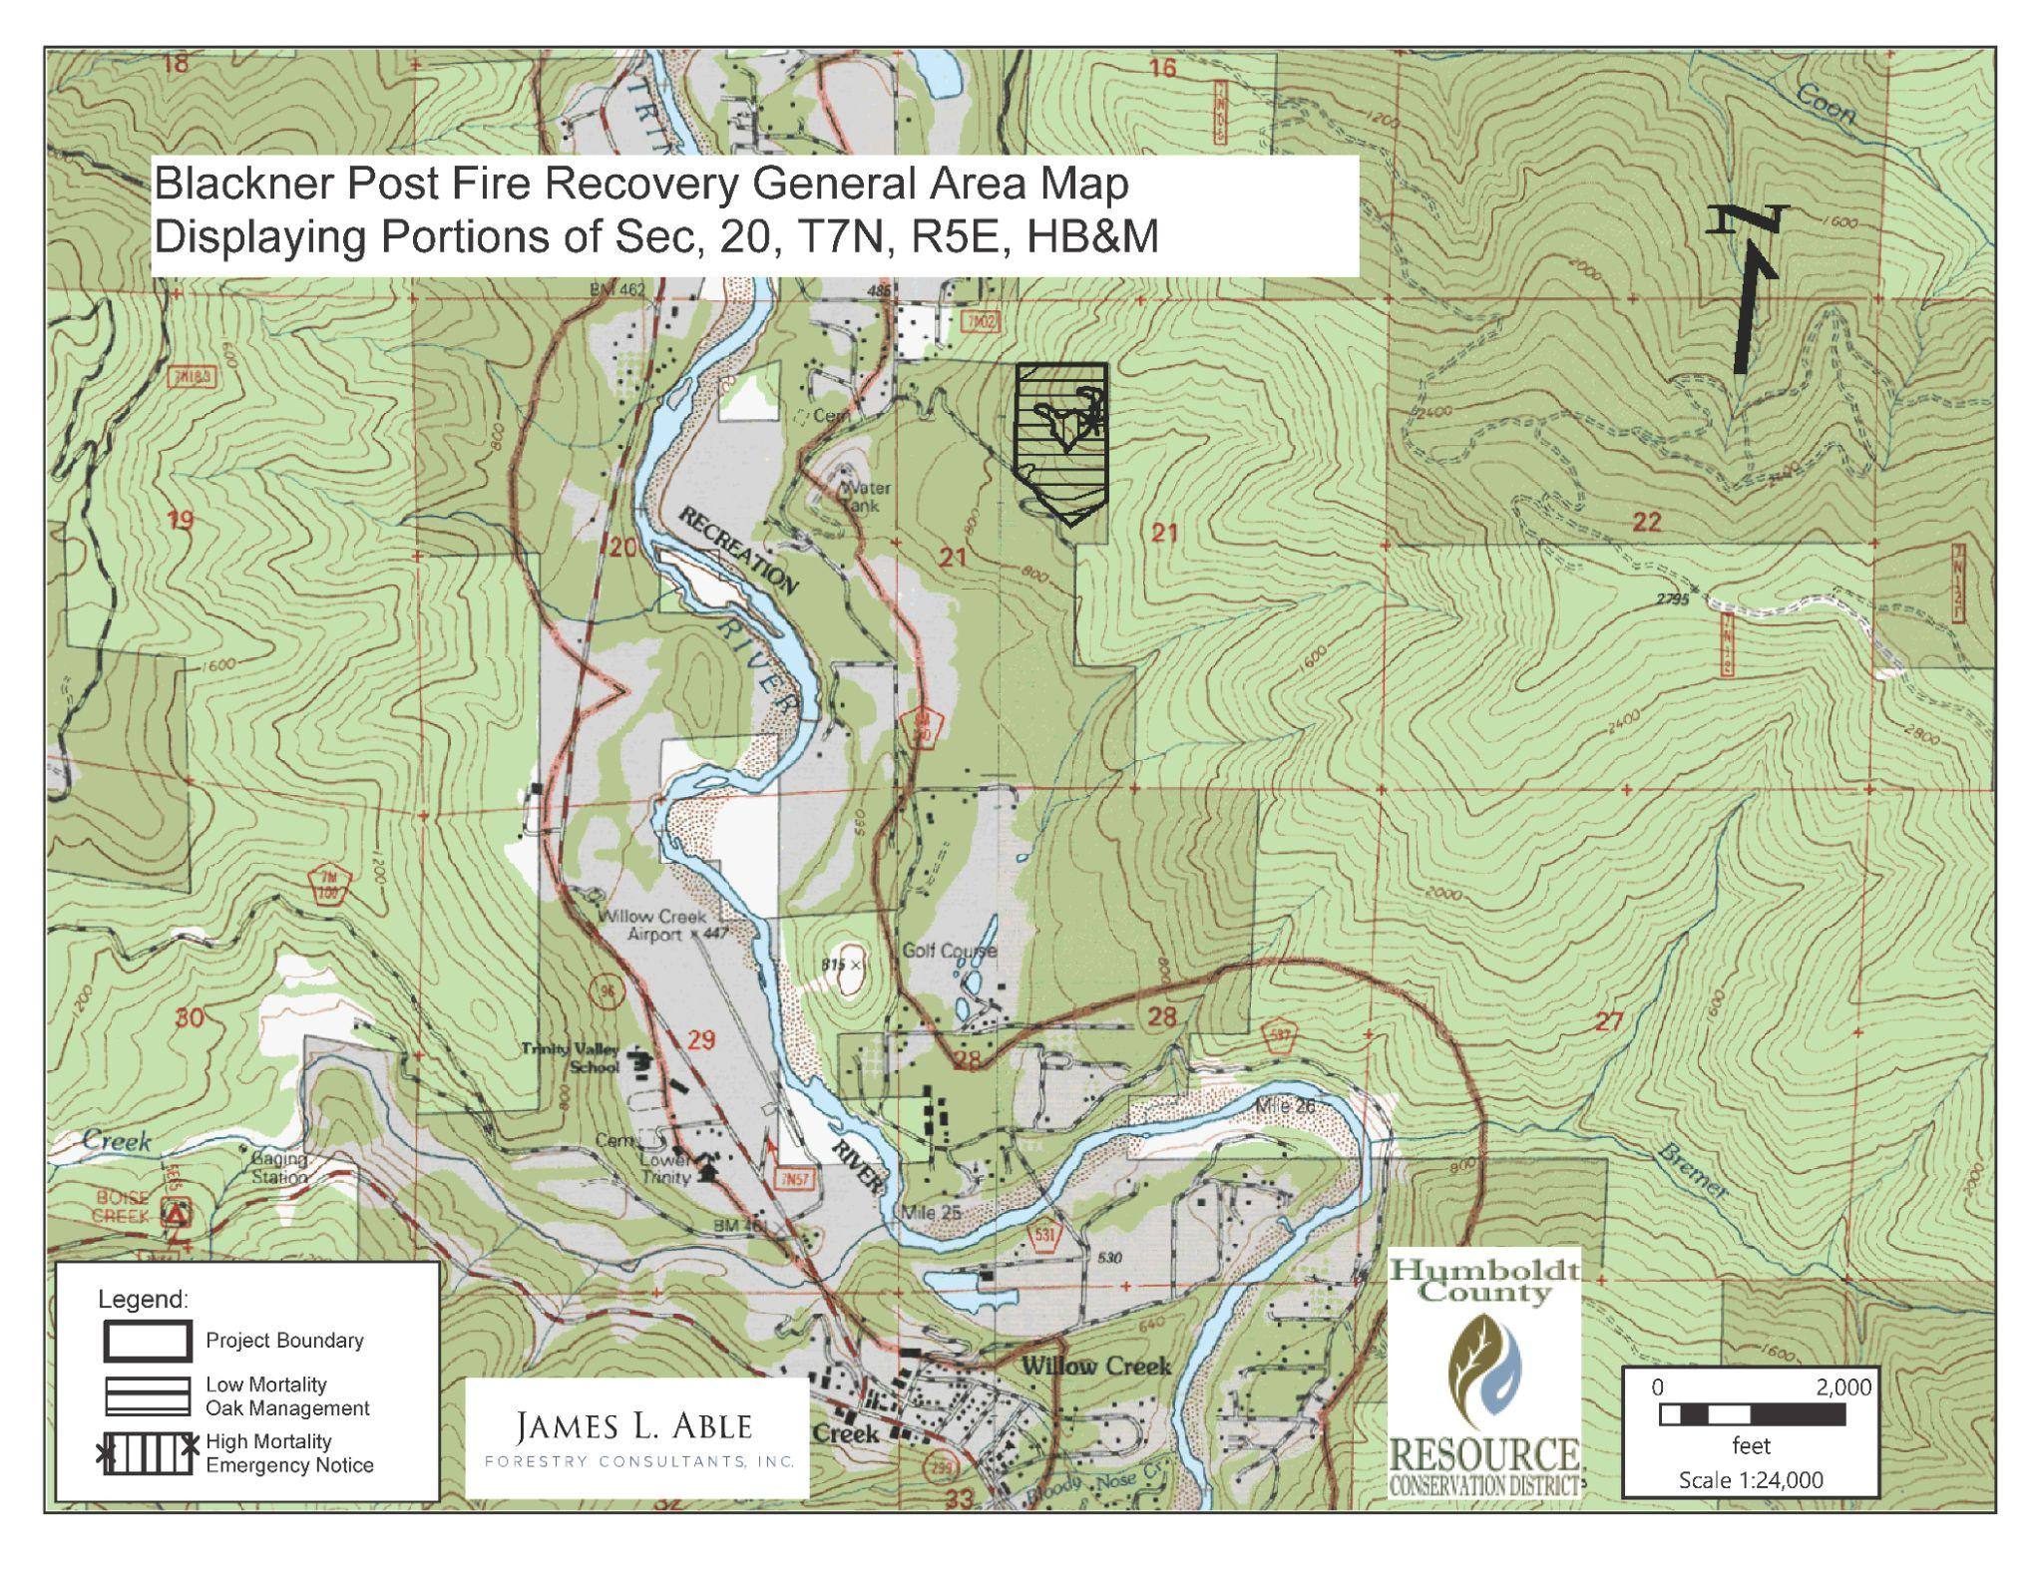

Figure 1: Unit Overview.

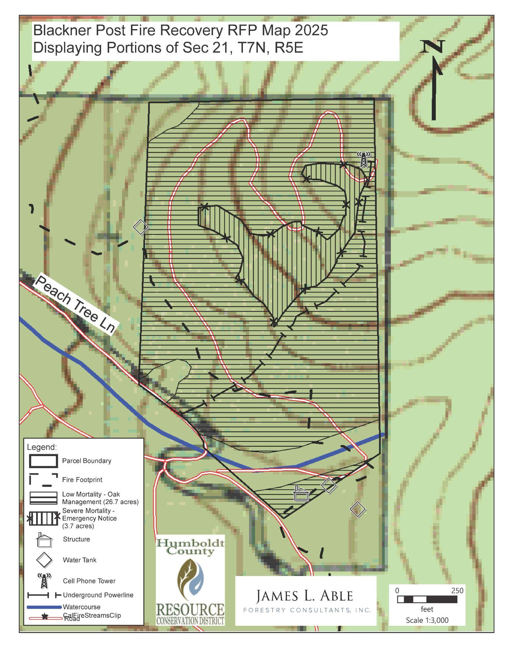

Figure 2: Unit Specifications.
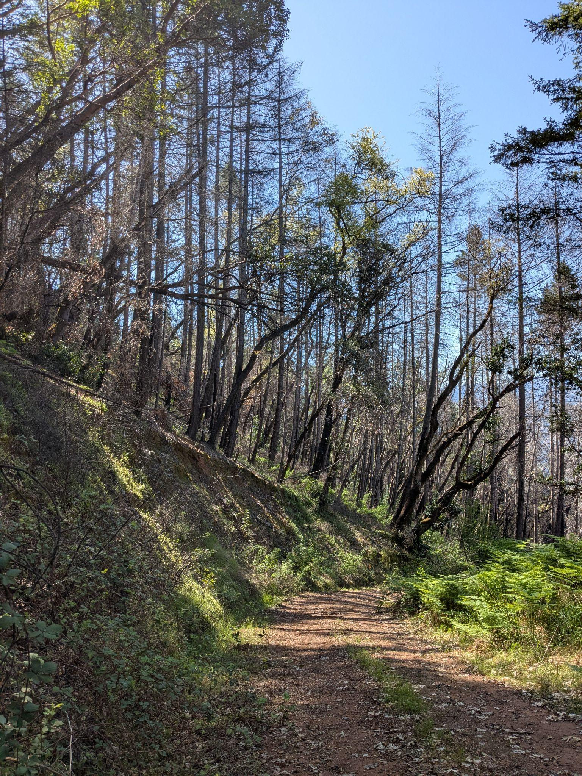
Figure 3: Site Conditions in Emergency Exemption project area.

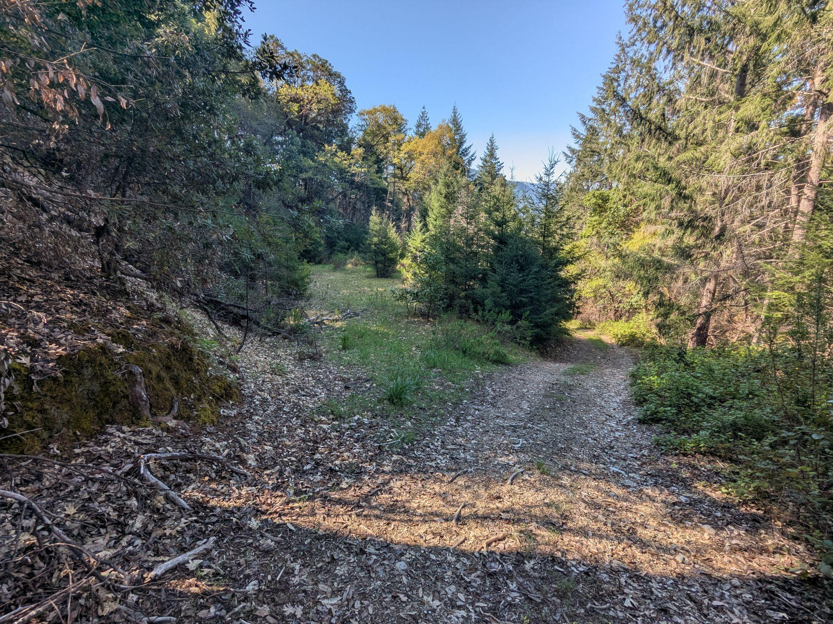
Figure 4: Site Conditions of access road with potential landing on left side.

EXHIBIT B – Proposal Template & Schedule of Items

Project Name: Post Fire- Six Rivers 2022 Restoration Project Phase 1

Contractor Information:

Company Name
Contact Name
Address
Phone
Email

Project Understanding and Approach: Provide a response in the space provided below. Please attach additional page(s) if required.

Equipment to be utilized: provide make and model for each piece of equipment
Key staff required; please note if you will subcontract any portion of this work (ex: LTO-A, mechanical or manual crews)
California Contractor License No. or other licenses as pertinent:
LTO-A License No.
Proposed schedule (start and end dates)
Estimated number of workdays to complete project (range of days)
Additional information (Optional):

Experience and Qualifications: Provide a general description of CONTRACTOR’s experience and qualifications regarding similar projects. Please attach relevant photos if available (maximum 2 photos).

Key Projects
Project 1
Project 2
Key Staff Names & Qualifications
Professional Reference 1 | Name | Affiliation | Telephone Number
Professional Reference 1 | Email Address
Professional Reference 2 | Name | Affiliation | Telephone Number
Professional Reference 2 | Email Address
Additional information (Subcontractors, Optional):

Cost Proposal: Submit a unit price and total price for the work outlined in the Schedule of Items, below. The Cost Proposal will be submitted based on the Schedule of Items. Estimated quantities are based upon the best available information at the time of advertisement of the RFP. Estimate cost per hour for both loading and transportation, as number of loads is undetermined. The unit prices will remain firm and will not be negotiated. In case of discrepancy between unit prices and totals, unit prices will prevail.

Schedule of Items: All projects are available for treatment upon Notice to Proceed.

ITEM NO. | TREATMENT | QUANTITY | UNIT | UNIT PRICE | TOTAL PRICE
1 | 30.4 Acres (Figure 1-4)
1 | Felling/Yarding | 30.4 | Acres
1 | Slash Treatment | 30.4 | Acres
1 | Loading | TBD | Hours |  | Undetermined
1 | Transportation | TBD | Hours |  | Undetermined
 |  |  |  | Total Cost

EXHIBIT C – Agreement Template

HUMBOLDT COUNTY RESOURCE CONSERVATION DISTRICT
CONTRACTOR AGREEMENT

This Agreement is made as of by and between , hereinafter referred to as “CONTRACTOR” and Humboldt County Resource Conservation District, hereinafter referred to as “DISTRICT” to provide contractor services for the Post Fire- Six RIvers 2022 Restoration Project, hereinafter referred to as “PROJECT”.
SCOPE OF WORK: DISTRICT is retaining CONTRACTOR to conduct the Project as defined in the Request for Proposal released by the DISTRICT on June 10, 2025 and hereby incorporated into this agreement as Exhibit 1.
The HCRCD contracted James L. Able Forestry Consultants, Inc. to provide Registered Professional Forester (RPF) services in association with this project.
NOTICE TO PROCEED: DISTRICT will issue a NOTICE TO PROCEED to the CONTRACTOR authorizing CONTRACTOR to proceed with PROJECT work upon receiving the following:
- Insurance certificates naming Humboldt County Resource Conservation District, its directors, officers, agents, and employees, as additionally insured as required by Section 3 of Exhibit 1.
COMPENSATION: The total value of this Agreement shall not exceed $ . Compensation is based on the following unit prices and actual acres treated:

TERMINATION DATE: This Agreement terminates on December 31, 2026 or expiration of insurance certificate, whichever comes first.
INVOICING: Invoices for services rendered and any fees due shall be submitted to the DISTRICT at 5630 South Broadway, Eureka, CA 95503 or katrina@hcrcd.org. CONTRACTOR may submit invoices for payment no more often than once a month and no less often than quarterly. Invoice(s) must include the following additional documentation:
a. Inspection by HCRCD designated Registered Professional Forester.
PAYMENTS: This Agreement is funded under federal funding awards from USDA, Forest Service, Region 5, State and Private Forestry, Federal Award Number 22-DG-11052021-206 or other funding sources as may be determined by DISTRICT. DISTRICT will provide payment to CONTRACTOR within 30 days of receipt of payment from the funder and will withhold up to 10% percent of the invoice amount until contract completion.
NOTICES: Any notice required to be given pursuant to the terms and provisions of this Agreement shall be in writing and sent via first-class mail. Notices shall be deemed effective two (2) days after mailing to the following addresses:
CONTRACTOR: DISTRICT:

For:
CONTRACTOR Humboldt County Resource Conservation District

By: By:

Name: Name:

Title: Title:

Date: Date:

Exhibit 1: Required Terms
CONTRACTOR agrees with the DISTRICT that:
1. CONTRACTOR is aware of the provisions of Section 3700 of the California Labor Code which requires every employer to be insured against liability for workers’ compensation or to undertake self-insurance in accordance with the provisions of that code, and CONTRACTOR will comply with such provisions before commencing the performance of the work of this Agreement. CONTRACTOR and any sub-contractors will keep workers’ compensation insurance for their employees in effect during all work covered by this Agreement.

2. CONTRACTOR waives all claims and recourse against the DISTRICT, including the right to contribution or indemnity for any claims, demands, damages, costs, expenses or liabilities for death or injury to persons or damage to property arising from, growing out of, or in any way connected with or incident to CONTRACTOR’S performance of this contract, except claims arising from the negligence of the DISTRICT, its directors, officers, agents, or employees. CONTRACTOR shall indemnify and hold DISTRICT, the landowners, its directors, officers, agents, and employees harmless from and against any and all claims, demands, damages, costs expenses, or liabilities from third parties arising from, growing out of, or in any way connected with or incident to CONTRACTOR’S performance of this contract, except claims arising from the negligence of the DISTRICT, its directors, officers, agents, or employees.

3. CONTRACTOR shall procure and maintain for the duration of the contract insurance against claims for injuries to persons or damage to property which may arise from or in connection with the performance of the work hereunder and the results of that work by the CONTRACTOR, its agents, representatives, employees, or subcontractors.
  - Specifically, CONTRACTOR will file with the DISTRICT before beginning work, certificates of insurance and policy endorsements satisfactory to the DISTRICT evidencing:
    - Commercial General Liability (CGL) and Loggers Broad Form (LBF). CONTRACTOR shall procure and maintain insurance applicable to third party claims related to performance of the Scope of Work, either through CGL or LBF or a combination of both. Such coverage shall be on an “occurrence” basis, including products and completed operations, property damage, bodily injury and personal & advertising injury with limits no less than $2,000,000 per occurrence. If a general aggregate limit applies, either the general aggregate limit shall apply separately to this project/location or the general aggregate limit shall be twice the required occurrence limit. The CGL and LBF insurance shall name and include DISTRICT, and their officers, directors, agents and employees, and the landowner as Additional Insureds using ISO additional insured endorsement CG 20 10 04 13 or its equivalent, which coverage shall be maintained for the benefit of the Additional Insureds for a period of one year following completion of the Scope of Work. Additional insured coverage as required in this paragraph shall apply as primary insurance with respect to any other insurance or self-insurance program available to the any of the Additional Insureds.
    - Comprehensive Automobile Liability Insurance. Comprehensive automobile liability insurance (Bodily Injury and Property Damage) on owned, hired, leased and non-owned vehicles used in conjunction with CONTRACTOR 's business of not less than $2,000,000 combined single limit per occurrence.
    - Workers’ Compensation insurance as required by the State of California, with Statutory Limits, and Employer’s Liability Insurance with limit of no less than $1,000,000 per accident for bodily injury or disease.
  - If the CONTRACTOR maintains broader coverage and/or higher limits than the minimums shown above, the DISTRICT requires and shall be entitled to the broader coverage and/or the higher limits maintained by the CONTRACTOR. Any available insurance proceeds in excess of the specified minimum limits of insurance and coverage shall be available to the DISTRICT.
  - Self-insured retentions must be declared to and approved by the DISTRICT. At the option of the DISTRICT, the CONTRACTOR shall provide coverage to reduce or eliminate such self-insured retentions as respects the DISTRICT, its officers, officials, employees, and volunteers; or the CONTRACTOR shall provide evidence satisfactory to the DISTRICT guaranteeing payment of losses and related investigations, claim administration, and defense expenses. The policy language shall provide, or be endorsed to provide, that the self-insured retention may be satisfied by either the named insured or DISTRICT.
  - Each insurance policy required above shall provide that coverage shall not be canceled, except with notice to the DISTRICT.
  - Insurance is to be placed with insurers authorized to conduct business in the state with a current A.M. Best rating of no less than A: VII if admitted in the State of California.
  - If any of the required coverages expire during the term of this Agreement, the CONTRACTOR shall deliver the renewal certificate(s) including the general liability additional insured endorsement to the DISTRICT at least ten (10) days prior to the expiration date.

4. Any change in the Scope of Work, method of performance, nature of materials or price thereof, or to any other matter materially affecting the performance or nature of the work will not be paid for or accepted unless such change, addition or deletion is approved in advance, in writing by a supplemental agreement executed by the DISTRICT.

5. Permits required by governmental authorities will be obtained by the CONTRACTOR and at the CONTRACTOR’s expense, and CONTRACTOR will comply with local, state and federal regulations and statutes including the Cal/OSHA requirements.

6. CONTRACTOR warrants that it is not currently debarred, suspended, proposed for debarment, declared ineligible, or otherwise excluded from or ineligible for participation in federal assistance programs under Executive Order 12549, “Debarment and Suspension”.

7. CONTRACTOR warrants that during the performance of this Agreement it shall not unlawfully discriminate against, harass, or allow harassment against any employee or applicant for employment because or any reason covered under law nor unlawfully deny family-care leave, medical care leave, or pregnancy-disability leave. CONTRACTOR further warrants that it will comply with the provisions of the Fair Employment and Housing Act (Gov. Code §12990 (a-f) et seq.) and the applicable regulations thereunder (California Code of regulations, title 2, Section 7285 et seq.) The applicable regulations of the Fair Employment and Housing Commission implementing California Code of Regulations Section 12990 (a-f) set forth in Chapter 5 of Division 4 of Title 2 of the California Code of Regulations, are incorporated into this Agreement by reference and made a part hereof as if set forth in full. Subcontractors shall give written notice of their obligations under this clause to labor organizations with which they have a collective bargaining or other Agreement.

8. CONTRACTOR asserts that they are in compliance with California’s Drug Free Workplace Act of 1990 and that they will provide a drug-free workplace by doing all of the following:
  - Publishing a statement notifying employees that the unlawful manufacture, distribution, dispensation, possession or use of a controlled substance is prohibited in the person’s or organization’s workplace and specifying the actions that will be taken against employees for violations of the prohibition; and
  - Establishing a drug-free awareness program to inform employees about all of the following: a) The dangers of drug abuse in the workplace, b) the CONTRACTOR’s policy of maintaining a drug-free workplace, c) any available drug counseling, rehabilitation and employee assistance programs, and d) the penalties that may be imposed upon employees for drug abuse violations; and
  - Requiring that each employee engaged in the performance of the contract or grant be given a copy of the statement required by subdivision (a) of the act and that, as a condition of employment on the contract or grant, the employee agrees to abide by the terms of the statement.

9. CONTRACTOR shall maintain acceptable management systems of financial accounts, documents, and records relating to this Agreement during the term of this Agreement. Such systems shall provide accurate, current and complete disclosure of the financial activity under this Agreement. CONTRACTOR shall retain these records for a minimum of three (3) years following the date of final disbursement by the DISTRICT under this Agreement, regardless of the termination date.

10. CONTRACTOR agrees to allow auditor(s) from the DISTRICT, United States of America, State of California, or their designated representative the right to review and to copy any records and supporting documentation pertaining to the performance of this Agreement. CONTRACTOR agrees to allow access to such records during normal business hours and to allow interviews of any employees who might reasonably have information related to such records. CONTRACTOR agrees to maintain such records for possible audit for a minimum of three (3) years after final payment.

