Request for Proposals

Willow Creek Shaded Fuel Break Phase 2 - Manual Fuels Reduction Services
Date Released: Monday, September 15, 2025
Request for Proposals Due: Wednesday, October 1, 2025 at 5pm P.S.T

Purpose
The Humboldt County Resource Conservation District (HCRCD), in partnership with the Willow Creek Fire Safe Council (WCFSC), Willow Creek Volunteer Fire Department (WCVFD), and Willow Creek Community Services District (WCCSD) (“Partners”), prepared this Request for Proposals (“RFP”) to hire a qualified Contractor to perform a range of fuel treatment services on privately owned lands in the unincorporated community of Willow Creek. The proposed activities are part of a grant-funded program to advance the goals of the 2019 Humboldt County Community Wildfire Protection Plan (“CWPP”), relevant to Willow Creek. The proposed activities are also consistent with actions outlined in documents within the Humboldt County CWPP, including the Countywide Action Plan and Willow Creek Area Planning Unit Action Plan.

Available Funds
Approximately $500,000.00 in grant funding is currently available to implement manual fuels reduction treatment on 101.5 acres across two project areas. Contractor selection for any given body of work will be based on a combination of associated qualifications and experience, availability when services are required, and cost control measures. No bid walk will occur for this RFP; georeferenced maps can be provided upon request and pictures of site conditions are included. This project is funded by the USDA Forest Service. The USDA Forest Service is an equal opportunity provider.
Please note that payments for invoices are subject to the reimbursement schedule dictated by the funder and may be delayed up to 90 days from HCRCD’s receipt of contractor’s invoice and submission of reimbursement request.

Project Areas
The Willow Creek Shaded Fuel Break Phase 2 – Manual Fuels Reduction Services is located in Willow Creek in Humboldt County, California in SEC 17, 18, & 29 T7N R5E HB&M. The project areas are a mix of dense conifer forest and oak woodlands with steep to gentle terrain. All work occurs on private property. The region has experienced several large wildfires over the last 4 years and also experienced a significant storm event in 2021 that caused many large trees to fall within the project areas. Project area maps and site characterization photos can be found in Attachment A.

The two project areas have been defined as follows:
- Unit 1: Western Willow Creek Gateway
- 52-acre unit between HWY 96 and Brannan Mountain Road. Project area includes significant downed vegetation and densely populated mixed conifer and hardwood forest.
- 0-70% slopes
- Attachment A: Figures 1-4
- Unit 2: Upper Patterson
- 49.5 acre unit adjacent to Horse Linto Road and US Forest Service land. Project area includes mature hardwoods and densely populated small diameter conifers.
- 0-60% slopes
- Attachment A: Figures 5-7
Scope of Services
The Contractor is required to comply with all terms and requirements as defined in the Request for Proposals. The types of services that may be required to complete this project include the following:
- Manual Fuels Reduction: Removal of hazardous vegetation, including shrubs, brush, and small diameter trees, to increase horizontal spacing and eliminate vertical continuity of fuels. Where feasible, vigorous regrowth will be deterred by promoting a closed canopy of healthy overstory trees. Attachment B: General Description of Manual Fuels Reduction. Vegetation shall be chipped, lopped and scattered or piled and burned. For more details see Attachment C: Best Management Practices (BMP) for Pile Burning of Cut Debris. Contractors must have insurance that covers pile burning under either Commercial General Liability or Loggers Broad Form. Contractors may subcontract this portion of the work to meet insurance requirements. Please see Attachment D: Insurance Requirements.

General
- It is not the intent of the specifications to cover each and every detail. Any problems that may arise must be promptly reported to the HCRCD or Partners and will be subject to the decision of the HCRCD. The CONTRACTOR is expected to carefully examine the size and scope of the proposed work prior to submitting its proposal. The CONTRACTOR certifies it has checked carefully all the quantities, specifications, maps and figures, and understands that the HCRCD nor Partners will not be responsible for any errors or omissions on the part of the CONTRACTOR in compiling and submitting this proposal.

- The CONTRACTOR agrees that they will provide the materials and/or perform the work herein under the terms and conditions set forth in the awarded contract; and shall furnish and be responsible for all the labor, materials, tools, equipment, transportation, insurance, notifications, licenses, permits, and all other services and facilities necessary, including all incidental work and appurtenances as may be reasonably implied and as described in the specifications and other Contract documents. All costs incidental to these requirements will not be paid for separately but shall be included in the work, including testing, if needed. CONTRACTOR shall be responsible to pay all costs for permits, licenses, fees and insurance which may be required to perform the work required.

- CONTRACTOR will obtain and maintain in full force and effect throughout the term of this Project, and thereafter as to matters occurring during the term of this Project, the insurance coverage as specified in Attachment D: Insurance Requirements.

- Any portion or aspect of the property, including but not limited to roads, trails, gates, fences, culverts and/or drainage structures, or signs or other improvements damaged by CONTRACTOR will be repaired to a like or better condition at the end of the project as that found prior to the start of work. Repairs may include repairing or replacing drainage control features. Upon notice from HCRCD or Partners, significant damage to existing roads, trails or other improvements, caused by CONTRACTOR, must be repaired by CONTRACTOR at CONTRACTOR’s expense within ten (10) working days of the notification by the HCRCD or Partners.

- The work site should be left in a safe manner at the end of every workday, and the CONTRACTOR will take all reasonable precautions to avoid injury to the public.

- Before daily acceptance, all areas occupied by the CONTRACTOR in connection with the work shall be cleaned of all CONTRACTOR garbage, excess materials, temporary structures, and equipment, and all parts of the work area shall be left in a neat and presentable condition.

- Coordinate all work as necessary to complete the project, avoid damage to utilities and maintain utility service with each affected utility company.

Desired Qualifications
The following is a list of the desired qualifications and experience for contractors responding to this RFP:
- Experience with and ability to successfully complete the treatment types and/or activities described in the Scope of Services above.
- Own or have access to the appropriate equipment to provide the selected service(s) (e.g., a chipper of an adequate size to chip material generated from fuels reduction services).
- Experience with and ability to operate all necessary equipment safely, effectively, and efficiently.
- Ability to understand and comply with environmental compliance and other permitting requirements.
- Experience with and ability to work respectfully and cooperatively with community members and liaisons.
- Experience with and ability to work collaboratively with HCRCD and Partners on project design, coordination, photo documentation, reporting and invoicing.
- Knowledge of methods to reduce the spread of invasive species associated with fuels reduction activities.
- Knowledge and understanding of project budgeting and cost controls, particularly for grant funded projects.
- Ability and willingness to be flexible and responsive to evolving project needs.
- Possession of, or ability to secure and provide to HCRCD, the required insurance certificates (See Attachment D for the detailed list of insurance requirements).
- Crew is ideally no fewer than four personnel.

Submission Requirements

Please use Attachment E: Proposal Template to prepare the submission. Complete submissions shall be emailed to Jill Demers, Executive Director, HCRCD, at: jill@hcrcd.org. Hard copies will be accepted by appointment. Submissions must be received no later than 5pm, Wednesday, October 1, 2025.
Receipt of the submission will be acknowledged via email. No submittals will be accepted after this deadline. The following items may be submitted as a PDF file containing all required content.
- Cover Page:
  - Contractor name and contact details
  - Statement describing availability (i.e., How long in advance does work need to be scheduled? Can you be available on short notice for batches of work as needed? Are you more or less available during any given season?)
  - Confirmation that the required insurance detailed in Attachment D is in place or can be secured and certificates furnished to the HCRCD in a timely manner. Contractors should not purchase additional insurance intended to comply with these requirements until directed by the HCRCD as part of a final professional services agreement negotiation. HCRCD and Partners are not responsible for any contractor decisions to obtain additional insurance in anticipation of a potential contract under this RFP.

- Statement of Proposal for the services described in the Scope of Services section:
  - Submit a “Statement of Proposal” form provided in Attachment E.
  - Qualifications, including licenses applicable to the service.
  - Detailed descriptions and cost estimates, including:
    - General approach to providing the service (crew type and number of workers, equipment used, specific methods employed, average acres treated per day, etc.)
    - Cost per acre
    - Meaningful cost control measures, such as longer workdays or carpooling, hiring local crew members to reduce travel to project sites, experienced crew members to reduce training needs, knowledge and experience of working in Eastern Humboldt terrain, strategy to chip one day a week to reduce equipment costs

- Two professional references and brief explanation of relationship to contractor.

- (Optional) Provide two examples of before/after photos for similar types of projects completed by the contractor.

Evaluation and Selection Process
HCRCD and Partners will evaluate each proposal to determine the proposer’s qualifications. For this project the following evaluation criteria will be considered:
1. Budget (50%)
2. Prior experience and past performance (50%)

Budget (50%)
HCRCD and Partners seek the lowest responsible proposal that implies a realistic and achievable budget without burden to either party. Cost control measures will be evaluated.

Prior Experience and Past Performance (50%)
HCRCD and Partners require evidence that the contractor has the ability and capacity to successfully perform the Scope of Services. HCRCD and Partners will examine whether the firms have done similar work before, particularly in the Willow Creek area, and how well they have performed that work. HCRCD and Partners consider each firms’ performance records and professional reference reviews.

Submissions will be ranked based on the specific criteria in the table below (maximum of 100 points). The precise scope of services and the associated cost of those services will be incorporated into professional services agreements which will be the subject of negotiation between the HCRCD and the successful respondent(s) on an as-needed basis.

Scoring/Selection Criteria
Criteria | Points
Budget (50%)
Reasonable contractor rate and expenses | 40
Meaningful cost control measures | 10
Prior Experience and Past Performance (50%)
Demonstrated competence in the desired qualifications and experience outlined in this RFP | 30
Thoroughness, quality, and responsiveness of submission | 10
Quality and relevance of references | 10

Schedule
The following schedule of events represents the HCRCD’s best estimate of the schedule that will be followed with regard to this RFP process. HCRCD and Partners reserve the right to modify this tentative schedule as it deems necessary, including extending the deadline for submission of Statements of Proposals.

Date | Event
Monday, September 15, 2025 | RFP Issued
5 days before due date | Addendums issued, if necessary, to address contractor questions or provide clarity
Wednesday, October 1, 2025 (by 5:00 PM) | Completed submissions due to HCRCD: submitted to Jill Demers, Executive Director, jill@hcrcd.org
October 1-10, 2025 | Evaluation Process (interviews may be conducted as needed)
Friday, October 10, 2025 | Notice of Award.

Questions?
For questions about this RFP, contact:

Jill Demers, Executive Director, jill@hcrcd.org , 707-296-3992

Attachments
- Attachment A: Project Area Maps and Site Conditions:
  - Upper Patterson
  - Western Willow Creek Gateway
- Attachment B: General Description of Manual Fuels Reduction
- Attachment C: Best Management Practices (BMP) for Pile Burning of Cut Debris
- Attachment D: Insurance Requirements
- Attachment E: Proposal Template (Download Microsoft Word template)

Attachment A:
PROJECT AREA MAPS AND SITE CONDITION PHOTOS

UNIT 1: Upper Patterson
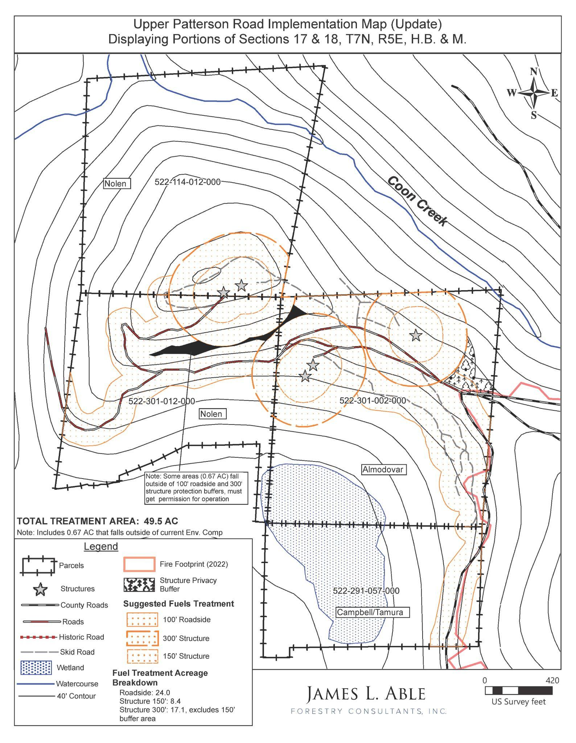
Figure 1. Upper Patterson Project Area Map
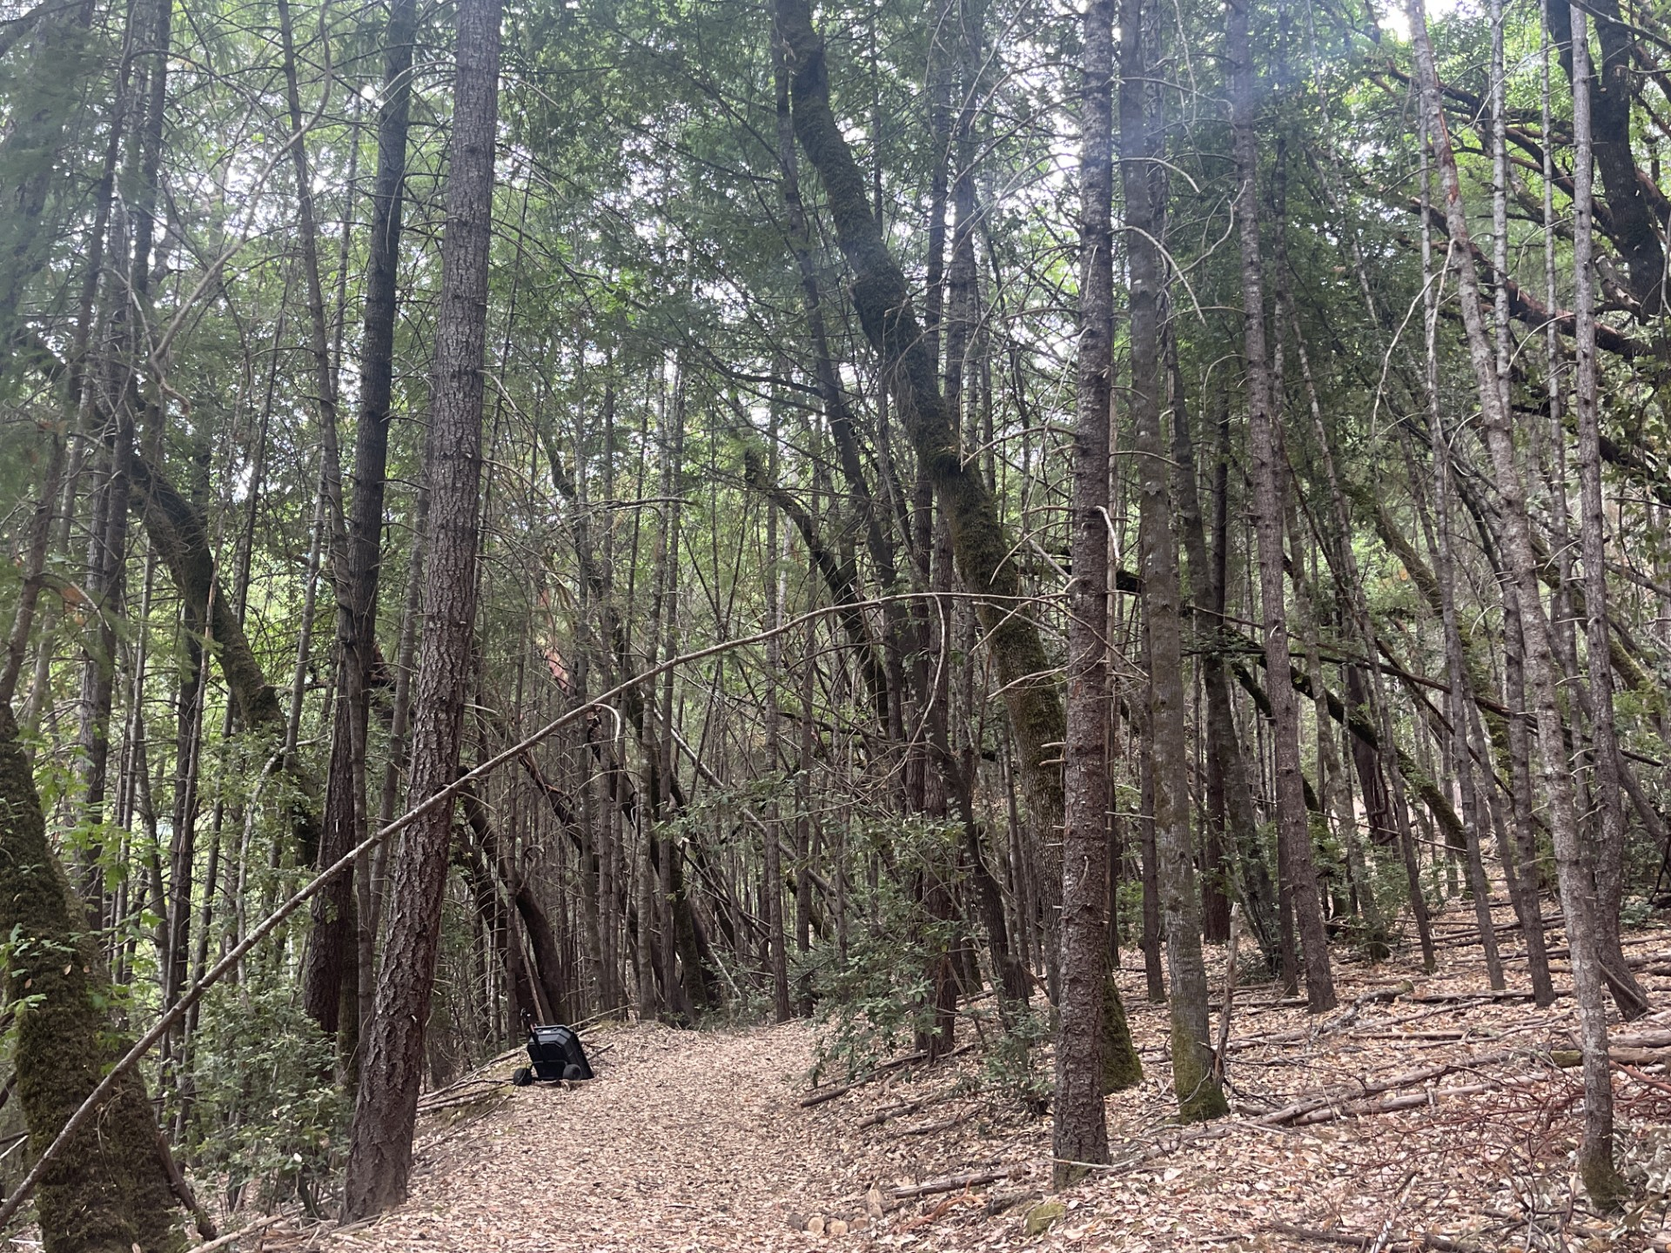

Figure 2. Upper Patterson Representative Site Conditions

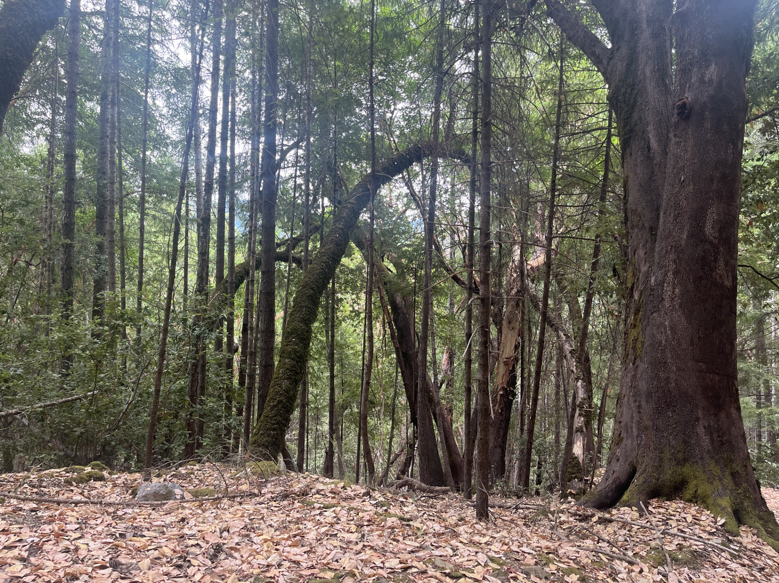
Figure 3. Upper Patterson Small Diameter Doug Firs within Legacy Hardwoods

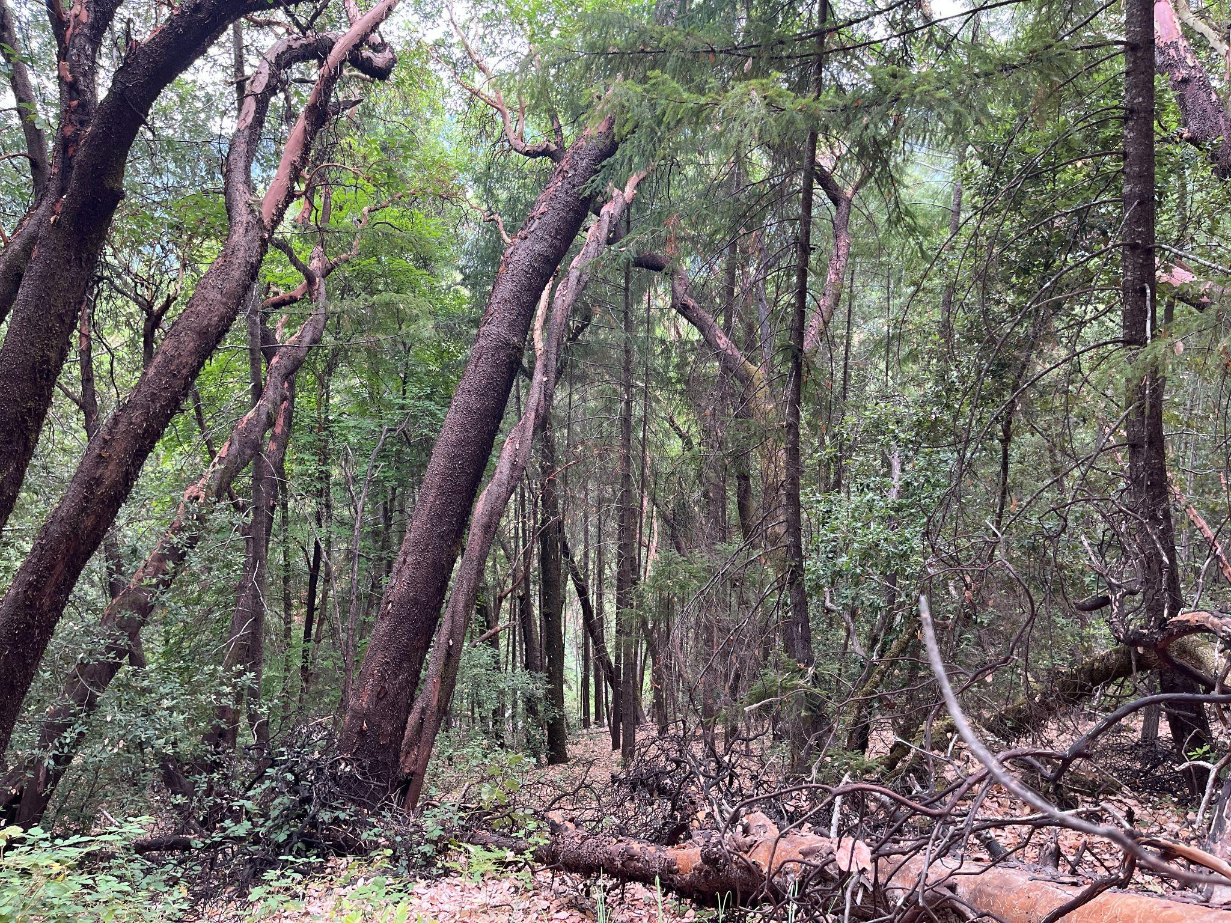
Figure 4. Upper Patterson Downed Trees

UNIT 2: Western Willow Creek Gateway
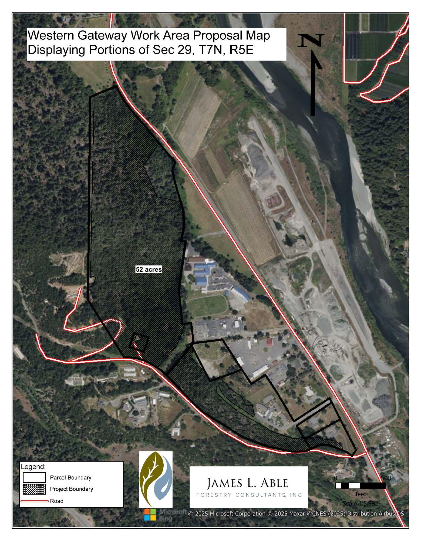
Figure 5. Western Willow Creek Gateway Project Map
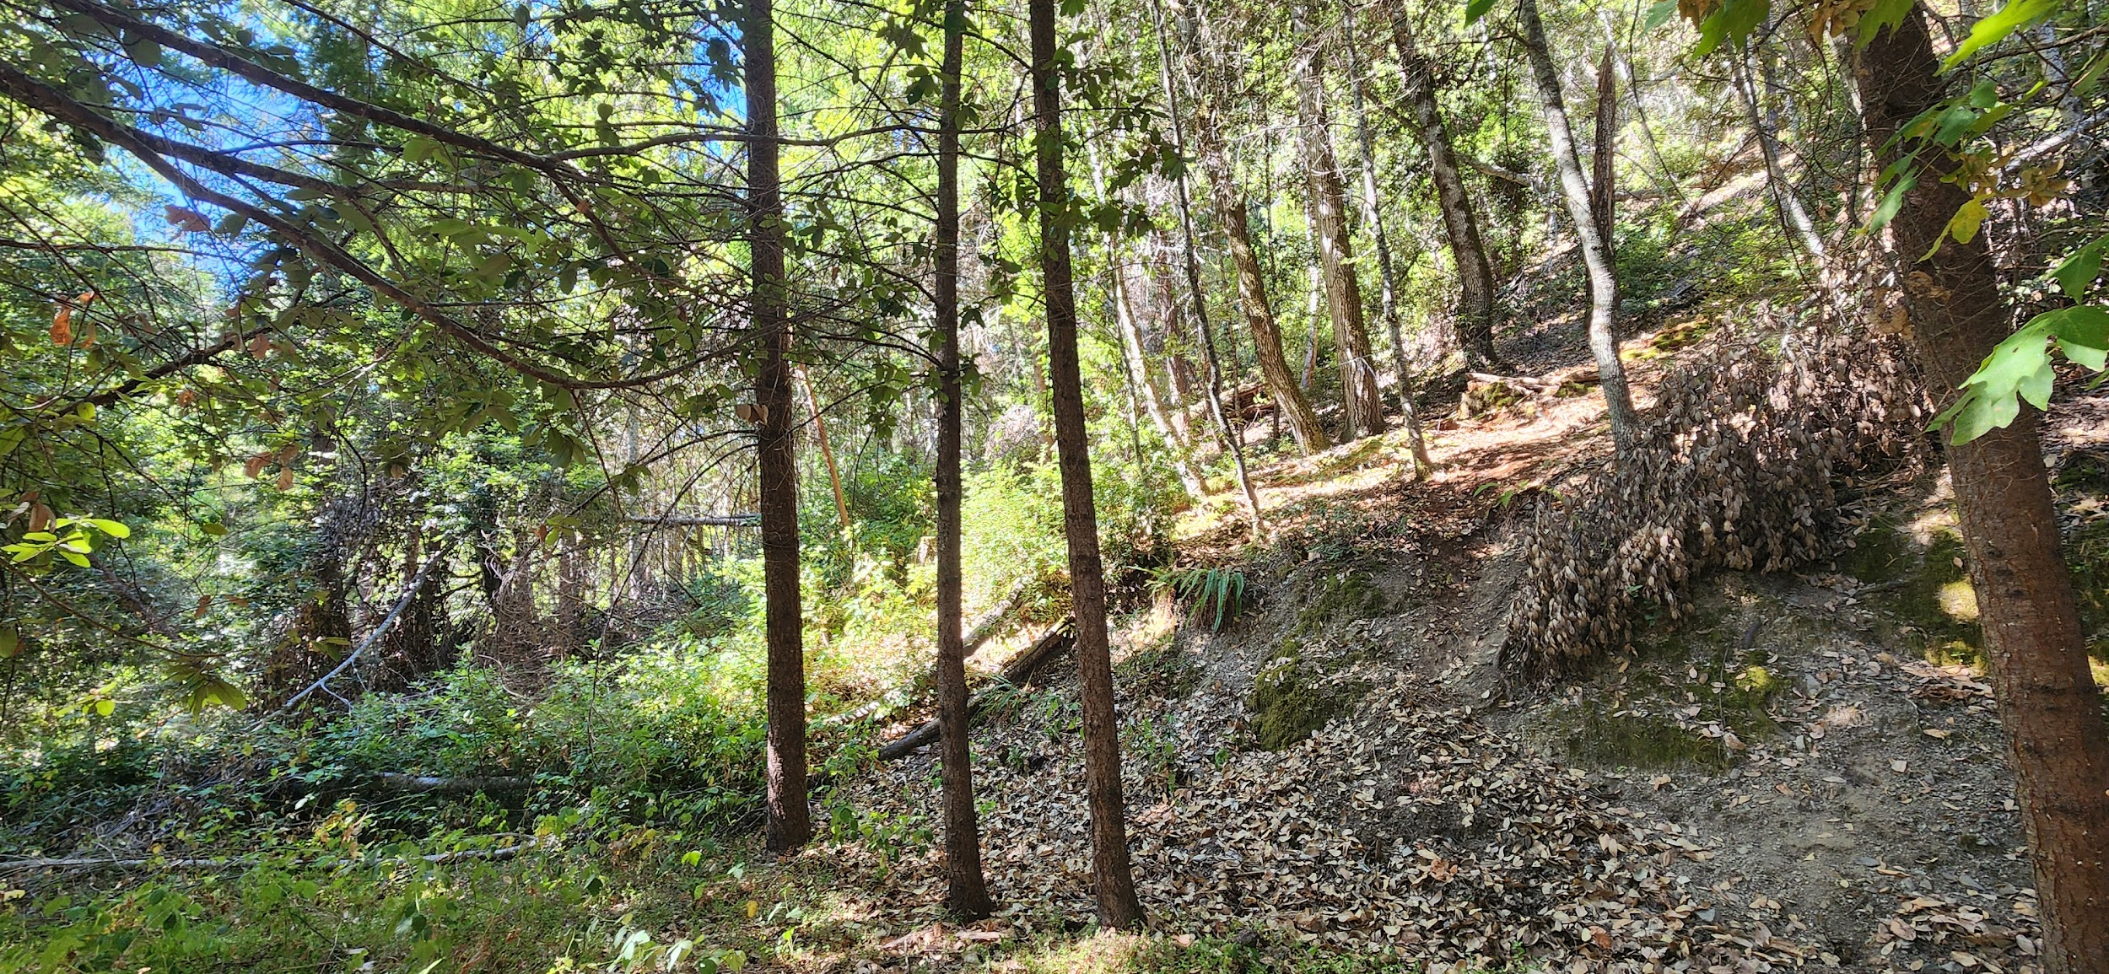
Figure 6. Western Willow Creek Gateway Example of Slope Steepness

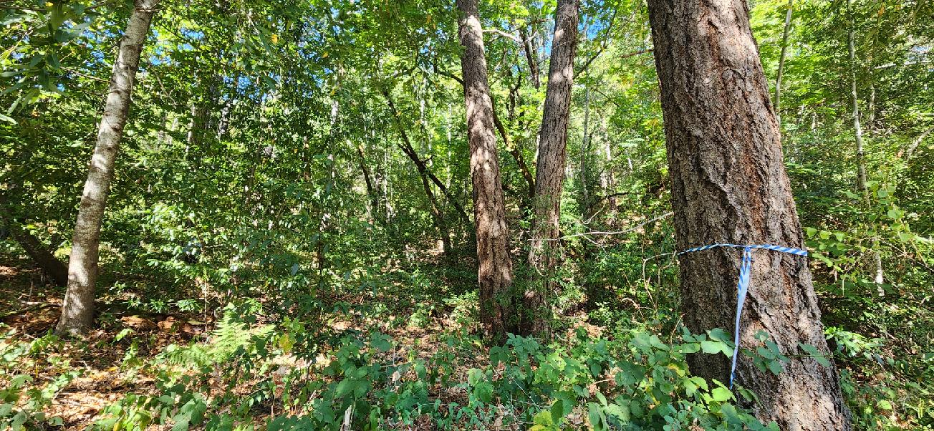
Figure 7. Western Willow Creek Gateway Representative Vegetation

Attachment B: General Description of Manual Fuels Reduction

Goal: The goal of this project is to reduce hazardous fuels to support forest health and resiliency.

Manual fuels reduction will be located on private property. Treatment types will vary based on conditions present and location-specific objectives but will generally include removing hazardous vegetation, including brush and small diameter trees, to increase horizontal spacing and eliminate vertical continuity of fuels. Where feasible, vigorous regrowth will be deterred by promoting a closed canopy of healthy overstory trees.

Activities implemented under the project’s California Environmental Quality Act (CEQA) exemption will be light touch vegetation treatment. The guidance provided below is intended to strike a balance between achieving project objectives and avoiding significant impact to natural resources. It is understood that additional site-specific decisions will be made by contractors using independent professional judgment or in consultation with HCRCD and Partners and, in some cases, forestry consultants.

Overview: Manual fuels reduction would reduce forest density by manual hand thinning and chipping as the primary treatment and lop and scatter or hand piling and burning as a secondary treatment. The third, more minor treatment would involve limbing of the healthy residual tree branches to 10-15 feet from the surface of the forest floor or the top of the existing vegetation, whichever is higher.

Tools: Tools used to implement the treatment may include hand tools including axes, Pulaskis, McLeods, weed wrenches, shovels, loppers, and hand and pole saws; and power tools including chainsaws, pole saws, and weedeaters (string and blade trimmers). In order to avoid soil disturbance, no heavy equipment or machinery will be used. Chippers will be operated from road beds or driveways, or other areas designated as acceptable locations by HCRCD and Partners.

Prescription

Prune trees, shrubs, brush, and other vegetation to create horizontal spacing between individual plants or groups of plants as well as a vertical separation between understory and overstory vegetation.
- Spacing of trees ≤8” DBH to an average of 10-30’ (trunk spacing), depending on terrain. Spacing may be lower in some areas and higher in others based on where healthy and desirable trees are present.
- Prune tree branches up to 10-15' high or 50% crown on smaller trees
- Prioritize removal of hazardous vegetation and dead trees ≤8” DBH
- Hardwoods that re-sprout, including tanoak and live oaks, should not be removed except where absolutely necessary. Instead, prune hardwood clumps to 1-3 dominant stems.
- Cut all brush except when necessary for cut-bank stabilization. Where trees are sparse, dominant brush may be selected as “leave trees” and left as 5’x5’ patch or pruned to dominant stem(s) if possible. 5x5 foot clumps should have a minimum separation of 15’.
- Stumps from cut brush and trees cut flat and left no higher than 4”
- Non-native species, such as but not limited to broom species, pampas grass, English ivy, holly, Himalayan blackberry, Tree of Heaven, and cotoneaster species, should not be retained unless requested by landowner. If they are too difficult to remove efficiently, they should be treated in a manner that reduces their potential for carrying fire from the ground up into the canopy. Broom species, holly, cotoneaster, and tree of heaven should be pulled by the roots if possible. Tree of Heaven and Broom species will not be chipped so as not to spread them to other areas.
- Tree species preference most to least desirable
  - Hardwoods
  - Conifer species other than Douglas fir
  - Douglas fir

Disposal
Preferred Disposal Method: The primary means of slash disposal will be chipping. Chipped material must be distributed back into the unit; avoid watercourses or any areas where chips may be transported to watercourses by heavy rains (i.e. road ditches). Where feasible, direct chips downhill to avoid chips washing into ditches unless there is known watercourse downslope. Chips do not need to be distributed uniformly (patchwork mosaic is OK at a depth no greater than 4”) but should not be left in piles. Chips may not be transported off-site without explicit permission from HCRCD.

Alternative Disposal Methods: In certain circumstances, where material generated will be limited and non-continuous, the “lop and scatter” method may be used. Slash must be cut into pieces small enough to maintain an average depth of less than 6 inches. Avoid accumulation of debris at the base of trees. Tree trunks must be limbed and cut into sections and all cut material should be arranged to maximize contact with the ground to encourage decomposition. This “lop and scatter” method must not be used within 100 feet of structures such as critical facilities, homes, or outbuildings.

In coordination with HCRCD and Partners, a plan may be made to employ several different methods of disposal for one project area. This may include areas where steep conditions hinder efficient dragging of material for chipping. In this case, “lop and scatter” may be used beyond 25 feet from the road on the downhill side; vegetation and woody debris in the first 25 feet must be chipped or removed.

In instances where other methods are infeasible or due to landowner specifications, CONTRACTOR may—with explicit permission from HCRCD—be permitted to hand pile slash for burning in a manner consistent with agreed upon Best Management Practices for Pile Burning of Cut Debris (Attachment B). It is the responsibility of the CONTRACTOR to burn piles unless explicitly stated otherwise.

Biological and Natural Resources:
The HCRCD will require that all contractors take an environmental awareness training provided by HCRCD or Partners prior to the commencement of implementation. HCRCD or Partners will provide more in-depth information regarding biological and natural resources avoidance measures during that training; general measures are below to aid in contractor response to RFP.

Water Resources: All ponds, fish-bearing streams, and smaller watercourses containing aquatic life (Class I and Class II watercourses under the California Forest Practice Rules) within an area proposed for treatment should be treated with the measures listed below. Within this riparian protection zone, treatment specifications are modified in order to reduce potential negative impacts to aquatic species, while also affording some reduction in the threat of wildfires.
- In order to avoid increasing water temperature, no vegetation that shades the surface of the water from sunlight during any part of the day shall be removed, whether trees, limbs, or brush, with exceptions for public safety.
- Crews will avoid walking in the stream channel or along its banks, except at occasional crossings, or within wet areas.
- No ground-disturbing activities.
- Vegetation removal will be reduced to not more than half the amount of removal outside the riparian area and will focus on removing fuels adjacent to the roadways, fuels with the potential to transfer fire into the tree canopy, and to break up the continuity of patches of surface fuels running parallel to the direction of slope. Patches of untreated vegetation will be retained, especially in the immediate vicinity of watercourses.
- No refueling or use of chemicals will be permitted within the Watercourse and Lake Protection Zone (WLPZ). WLPZ is determined for this project to be 100 feet within the watercourse.
- No piling and burning will be permitted within the WLPZ.
- Downed woody material that may provide habitat to amphibians or other species associated with riparian zones will be avoided and left on site.

Plants & Wildlife: Avoid areas identified by HCRCD or Partners as likely occupied by threatened and endangered plant and animal species, and other sensitive species. These species shall not be removed, or otherwise adversely affected, within any project area. No cutting or piling will occur within the occupied sensitive plant substrate.

Birds: To avoid impacts to nesting birds, during the critical period (March 1st- August 1th), CONTRACTOR will be required to complete a training that will assist in identification of potential species that can be found in the project areas. In addition, a certified or licensed responsible party will perform a visual survey of the project area to identify nests prior to beginning work in that area if work is to occur during this critical period.

If an active nest is identified, work will stop within 100 feet and the Contractor will notify HCRCD or Partners of the nest’s location, the HCRCD or Partners will have a certified or licensed responsible party assess the nest and provide guidance. If a listed species is observed, work will stop and the appropriate agency will be contacted for a consultation.

Cultural Resources: Cultural resources are a major resource and will be protected. CONTRACTOR will be expected to work with a cultural resource advisor during work on one of the project areas. HCRCD or Partners may direct CONTRACTOR to avoid certain areas in order to protect these resources. If a cultural resource site is discovered within a project area during operations, the following applies:
- Project activities within 100 feet of the newly discovered cultural resource should be immediately halted until HCRCD or Partners are contacted and measures are implemented to ensure avoidance of the site. Project activities may continue outside a 100-foot perimeter from the discovery during the identification and avoidance process.
- If the newly discovered site has been negatively impacted by project operations the HCRCD or Partners shall contact an Archaeologist to assist in development of protection measures and any necessary remediation.
- If the newly discovered site is a Native American Archaeological or tribal cultural resource (defined in CEQA), the HCRCD or Partners should notify the appropriate Native American tribal group and the Native American Heritage Commission, if appropriate.

Fueling: Fueling of chainsaws or refilling fuel containers must be done in a manner that prevents fuel from being dumped on roadways, in the forest, or within 100 feet of watercourses.

Waste: Temporary flagging and trash generated by Contractor shall be removed from project site and disposed of properly. No trash will be placed in piles or left at the job site (this includes old chainsaw parts).

Invasive Species and Disease: To minimize the risk of introducing or spreading invasive species, sudden oak death, or other invasive soilborne pathogens employ the following practices:
- If feasible, avoid operations during the time of year when transportation of seeds and pathogens is most likely (e.g. when ground is wet and seeds and spores can be picked up in the mud).
  - For more information about invasive plant species visit: https://www.cal-ipc.org/plants/profiles/
  - For more information on prevention of sudden oak death visit: http://www.suddenoakdeath.org/diagnosis-and-management/best-management- practices/
  - For more information on Port-Orford-cedar root disease review: https://www.fs.usda.gov/Internet/FSE_DOCUMENTS/stelprdb5332563.pdf

- Inspect and clean equipment and vehicles prior to entry or leaving the project site if the site is known to have sudden oak death.
  - Equipment inspection and cleaning should take place on a hard-paved or rocked surface as much as is feasible.
  - Avoid the transport of plant parts, e.g., weed seeds or parts of bay laurel and tanoak to prevent sudden oak death spread.
  - Use of an air compressor has been shown to be an effective means of cleaning equipment (chainsaws, tracked equipment, chippers, shovels, etc.).
  - Remove soil and plant debris from boots, clothes, and gloves.
  - If the site is known to have sudden oak death, consider treating equipment surfaces with sanitizers such as Lysol, 10% bleach solution, 70% isopropyl alcohol solution, or peracetic acid (H₂O₂).
- Pruned branches or chips generated from bay or tanoak trees shall not be removed from the area.

Noise: Hours of operation will be limited to the hours of 6 a.m. to 6 p.m. Monday-Friday, unless specified by HCRCD or Partners, to minimize the potential for noise impacts on residences near and within the project area. All equipment used in site preparation will meet or exceed State standards for noise control. Weekend work is allowed with written permission from HCRCD.

Exposure to Smoke, Dust and Fumes: All equipment will conform to California emission standards.
Fire Prevention: HCRCD or Partners will coordinate with the contractor to stop or reduce work hours during periods of increased predicted fire risk based on local fuel and weather data. Contractor should anticipate work stoppage to occur during Red Flag Warnings or days with Adjective Ratings of Very High or Above.
Attachment C: Best Management Practices (BMP) for Pile Burning of Cut Debris
Purpose
This document provides Best Management Practices (BMPs) for pile burning of cut debris to be disposed of while implementing the project. The contractor will be required to comply with these BMPs under any contract for the project.

Debris Disposal
For fuel reduction to be effective, the vegetation or debris that is cut must be modified or disposed of. In certain circumstances, HCRCD or Partners will determine to use pile burning to dispose of such vegetation. In some circumstances, pile burning will increase the efficiency of the debris removal, though compliance with BMPs is required to reduce potential risks and impacts.

Permitting and Smoke Management Plans
All burn permit requirements for the State of California and County of Humboldt will be followed before any pile burning is implemented. These include a North Coast Unified Air Quality Management District (NCUAQMD) burn permit and if required, a CAL FIRE burn permit. Required permits will be obtained by LANDOWNER prior to any burning, and HCRCD or Partners will provide a Smoke Management Plan (SMP) (if required) that will be managed and followed by the CONTRACTOR during any pile burning, for all parcels in which the pile burning will take place.

North Coast Unified Air Quality Management District
Currently, the NCUAQMD has two types of pertinent burn permits: a Standard Burn Permit authorizes an individual to burn a maximum of one pile (4' in diameter) at a time of approved materials and a Non-Standard Burn Permit allows the burning of one (1) 10-foot diameter burn pile at a time on a 1-acre property, unless otherwise approved for larger burns (1-10 acres+), multiple piles, or other types of burning such as property development, hazard reduction, prescribed burns, etc. If the pile burning is part of a larger project with multiple piles, parcels or landowners, a Non-Standard Burn Permit is required. The NCUAQMD mandates that burned vegetation must be sufficiently dried that it will not negatively impact air quality. For more information on obtaining a Non-Standard Burn Permit, visit: www.ncuaqmd.org/non-standard-burn-permits
A Smoke Management Plan (SMP) may be required depending upon the type, size, or location of the pile burning. SMPs are always required when a burn has the potential to impact nearby sensitive receptors (homes, schools, businesses, roads, etc.). Generally, an SMP is required if the quantity of material to be burned equals or exceeds one acre of material per calendar day. For more information on Smoke Management Plans visit: www.ncuaqmd.org/smoke-management-plans
If required, an SMP Application must be completed for the entire project scope and must include supporting mapping and the NCUAQMD SMP spreadsheet. SMP’s must be submitted at least thirty (30) days prior to burning, to allow for review and approval by the District, which may take longer during the peak prescribed burning periods of the year (September - November and April - June).
Non-Standard Burn Permits will be filled out for each landowner and parcel and submitted with an SMP that accounts for all parcels associated with the project. The requirements and guidelines identified within the approved North Coast Air Quality Management District burn permit must be followed. Please note that requirements may change between issuance of this RFP and project implementation; CONTRACTOR is required to follow all then-current laws, policies, and NCUAQMD requirements.

CAL FIRE Burn Permits
If the project is located in a State Responsibility Area (SRA), a CAL FIRE Burn Permit may be required. These permits are required from May 1st until the end of Fire Season is declared by CAL FIRE (after sufficient rainfall has ended significant risk). CAL FIRE has the following burn permit options:
- LE-6a is required for small residential projects with piles less than 4x4. These can be issued at the time of application (no site visit).
- LE-5 is required for all 'large or hazardous' burn projects. This means projects with piles larger than 4x4.
LE 5 permits may require a site visit from your local CAL FIRE Battalion Chief to evaluate your project for safety, and set ‘precautionary requirements’ such as control line specifications and minimum resources. These permits can take up to 10 days to process, and CAL FIRE Staff become less available as fire season progresses. As of 2023, the permitting process has moved online: burnpermit.fire.ca.gov. The local Battalion Chief or CAL FIRE Station can also be contacted for assistance with these permits. Please note that requirements may change between issuance of this RFP and project implementation; CONTRACTOR is required to follow all then-current laws, policies, and CAL FIRE requirements.

If the project is located in a Local Responsibility Area (LRA) or Federal Responsibility Area (FRA), alternate regulatory requirements may be imposed. CONTRACTOR is required to follow all applicable laws and requirements.

Project Burn Permit and SMP Management and Implementation
CONTRACTOR is responsible for ensuring that the required permits and plans have been obtained before commencing any pile burning. Digitized copies of the pertinent permits and Smoke Management Plans will be shared with the CONTRACTOR by HCRCD or Partners. CONTRACTOR is responsible for coordinating with HCRCD or Partners to document size and location of any piles created. HCRCD or Partners to document size and location of any piles created.
After obtaining the required permits and approval of the project SMP, pile burning may commence during Permissive Burn Days only. To determine Burn Day status, call 866-287-6329 (1-866-BURNDAY). Burn hours are from 6:00 a.m. until one hour before sunset. Some Non-Standard permits may also require the responsible party to obtain a Burn Authorization Number from the District prior to ignition. The CONTRACTOR is the responsible party for this Project. The Burn Authorization Number must be obtained by calling the NCUAQMD the morning that pile burning will be conducted. It is also important to notify the nearest Local Government Fire Agency and CAL FIRE. The Humboldt County Fire Services Web Map can be used to reference the pertinent Local Government Fire Agency. The North Coast Unified Air Quality Management District (NCUAQMD) requires a minimum of 15 days for piles to dry to reduce the toxic smoke associated with burning green materials.

Environmental Compliance Considerations
The HCRCD and Partners comply with the CEQA and other environmental laws. This project is categorically exempt from CEQA and a Notice of Exemption (NOE) or Secretarial Suspension for the program has been filed by the HCRCD. These treatments will not result in significant or permanent effects on the landscape or in the taking of rare, endangered, or threatened species of plants or animals. Treatments conducted under this exemption do not trigger the requirement for a permit under the County Streamside Management Areas and Wetlands Ordinance when they are routine maintenance activities intended to support, keep, and continue defensible space. Site-specific precautions may be necessary for work within Streamside Management Areas (generally 100 feet from top of bank for perennial streams, 50 feet from intermittent streams) to avoid unintended significant environmental impacts. The project involves a light-touch approach that balances project objectives related to wildfire preparedness with avoiding significant impacts to natural resources.

Pile Burn Location
Burn piles must be located on previously disturbed ground, primarily residential home sites, and road cuts. Road cuts and other disturbed ground will be identified based on the presence of a linear escarpment with no apparent natural cause on the uphill edge, usually with a fill slope on the downhill edge. Trees on the old driving surface will be younger than the age of last disturbance, generally less than 30” DBH, and stumps of old-growth trees will be absent. Centers of burn piles will be located as near the base of the cut bank as practicable. HCRCD or Partners may provide additional pile placement requirements or recommendations.

Site Preparation
Burn piles will be located in advance as crews are working through an area and will be placed so as to minimize damage to retained trees. Pile locations will be inspected for lithic scatter, chips, points, bone or similar resources that may have been washed down onto the disturbed area over the years. If any such material is found, HCRCD or Partners will be notified immediately and burn pile preparation will cease. Piles will be ringed and scraped to bare earth to eliminate pile escapes. On slopes, a trench will be installed below the pile to catch potential roll out.

Debris Piles
The objective of pile burning of debris is to reduce the fuels that contribute most to fire spread rate: the smaller, flashier fuels that consist mostly of leaves, twigs and stems less than 1” diameter. Debris should be cut for efficient handling, with large-end diameter generally 1 to 3 inches. Larger pieces can be limbed and bucked to maximize ground contact, and oriented parallel to the fall line where feasible or made available for firewood. Piles should be no larger than 10 ft x 10 ft for Non-Standard Burn Permits or 4 ft in diameter for Standard Burn Permits.

Burning
Before vegetation is lit, fire control mitigation must be prepared. This must include either a charged water hose that has the capacity to spray the surrounding area, or hand tools and a cut line down to mineral soil around the fire area. The personnel that are starting the ignition must have communication ability to contact the local fire agency, CAL FIRE, or call 9-1-1 if they are unable to control the fire and it threatens to become a structure fire or wildfire. Ignition accelerants including fuel, oil or other flammables may only be used with explicit permission from HCRCD. With the approval of all of the previous authorities and the explicit permission from the landowner and resident, burning may commence.
Piles are to be hand-fed at a rate that avoids detrimental scorching of the crowns of retained trees. Fuel should not include noxious or poisonous vegetation that could potentially make residents sick. Note that the objective is to reduce fuels to reduce fire hazard and rate of spread. It is not necessary to leave behind a ground surface that is 100% free of flammable debris. Fuel must be strategically loaded to account for the timing necessary to burn down and be able to be extinguished before the end of the work day, or one hour before sunset. The resident/landowner must be given notice of the situation and instruction on how to monitor for unexpected flare-ups and what to do in the case of an escape, or problematic smoke. Consideration should be given to the final condition of the resident’s home site and when necessary, ash and charcoal may need to be moved out of the immediate area or spread out.

Attachment D: Insurance Requirements

HCRCD INDEMNIFICATION AND INSURANCE REQUIREMENTS FOR PROFESSIONAL SERVICES AGREEMENTS

INDEMNIFICATION:

- Hold Harmless, Defense and Indemnification. CONTRACTOR shall hold harmless, defend and indemnify HCRCD, its Partners, the Landowner, and their agents, officers, officials, employees and volunteers from and against any and all claims, demands, losses, damages, liabilities, expenses and costs of any kind or nature, including, without limitation, attorney’s fees and other costs of litigation, arising out of, or in connection with, CONTRACTOR’s performance of, or failure to comply with, any of the duties and/or obligations contained herein, including the performance or nonperformance of any of CONTRACTOR’s agents, officers, directors, employees, assignees, or subcontractors.

- Effect of Insurance. Acceptance of the insurance required by this Agreement shall not relieve CONTRACTOR from liability under this provision. This provision shall apply to all claims for damages related to CONTRACTOR’s performance hereunder regardless of whether any insurance is applicable or not. The insurance policy limits set forth herein shall not act as a limitation upon the amount of indemnification or defense to be provided hereunder.

INSURANCE REQUIREMENTS:

This Agreement shall not be executed by HCRCD, and CONTRACTOR shall not be entitled to any rights hereunder, unless certificates of insurance, or other proof that the following provisions have been complied with, are filed with the HCRCD.

- General Insurance Requirements. Without limiting CONTRACTOR’s indemnification obligations set forth herein, CONTRACTOR, and its subcontractors hereunder, shall take out and maintain, throughout the term of this Agreement, and any extensions thereof, the following policies of insurance, placed with insurers authorized to do business in the State of California with a current A.M. Bests rating of no less than A: VII or its equivalent against personal injury, death and property damage which may arise from, or in connection with, all of the activities of CONTRACTOR and its agents, officers, directors, employees, assignees or subcontractors:

  - Comprehensive or Commercial General Liability Insurance at least as broad as Insurance Services Office Commercial General Liability Coverage (occurrence form CG 0001), in an amount of One Million Dollars ($1,000,000.00) per occurrence for any one (1) incident, including, without limitation, personal injury, death and property damage. If a general aggregate limit is used, such limit shall apply separately hereto or shall be twice the required occurrence limit.
    - Please ensure your insurance covers pile burning under either Commercial General Liability or Loggers Broad Form.

  - Automobile/Motor Liability Insurance with a limit of liability not less than One Million Dollars ($1,000,000.00) combined single limit coverage. Such insurance shall include coverage of all owned, hired and non-owned vehicles and be at least as broad as Insurance Service Offices Form Code 1 (any auto).

  - Workers’ Compensation Insurance, as required by the California Labor Code, with statutory limits, and Employers Liability Insurance with a limit of no less than One Million Dollars ($1,000,000.00) per accident for bodily injury or disease.
- Special Insurance Requirements. Said policies shall, unless otherwise specified herein, be endorsed with the following provisions:

  - The Comprehensive or Commercial General Liability Policy shall provide that HCRCD, Partners, and their agents, officers, officials, employees and volunteers, are covered as additional insured for liability arising out of the operations performed by, or on behalf of, CONTRACTOR. The coverage shall contain no special limitations on the scope of protection afforded to HCRCD, Partners, or their agents, officers, officials, employees and volunteers. Said policy shall also contain a provision stating that such coverage:
- Includes contractual liability.
- Does not contain exclusions as to property damage caused by explosion or collapse of structures or underground damage, commonly referred to as “XCU Hazards.”
- Is the primary insurance with regard to HCRCD and Partners.
- Does not contain a pro-rata, excess only and/or escape clause.
- Contains a cross liability, severability of interest or separation of insureds clause.

  - The above-referenced policies shall not be canceled, non-renewed or materially reduced in coverage without thirty (30) days prior written notice being provided to HCRCD in accordance with the notice requirements set forth herein. It is further understood that CONTRACTOR shall not terminate such coverage until HCRCD receives adequate proof that equal or better insurance has been secured.

  - The inclusion of more than one (1) insured shall not operate to impair the rights of one (1) insured against another insured, and the coverage afforded shall apply as though separate policies had been issued to each insured, but the inclusion of more than one (1) insured shall not operate to increase the limits of the insurer’s liability.

  - For claims related to this Agreement, CONTRACTOR’s insurance is the primary coverage to HCRCD and Partners, and any insurance or self-insurance programs maintained thereby are excess to CONTRACTOR’s insurance and will not be used to contribute therewith.

  - Any failure to comply with the terms and conditions of this Agreement shall not affect the coverage provided to HCRCD, Partners or their agents, officers, officials, employees and volunteers.

  - CONTRACTOR shall furnish HCRCD with certificates and original endorsements affecting the required coverage prior to execution of this Agreement. The endorsements shall be on forms approved by the HCRCD. Any deductible or self-insured retention over Fifty Thousand Dollars ($50,000.00) shall be disclosed to, and approved by, HCRCD. If CONTRACTOR does not keep all required policies in full force and effect, HCRCD may, in addition to any other available remedies, take out the necessary insurance and deduct the cost of said insurance from the monies owed to CONTRACTOR under this Agreement.

  - HCRCD is to be notified immediately if twenty-five percent (25%) or more of any required insurance aggregate limit is encumbered, and CONTRACTOR shall be required to purchase additional coverage to meet the above-referenced aggregate limits.

- Insurance Notices. Any and all insurance notices required thereunder shall be sent to the addresses set forth below in accordance with the notice requirements contained herein.

HCRCD: Humboldt County Resource Conservation District
Attention: Jill Demers, Executive Director
5630 S Broadway St.
Eureka, CA 95503

Contractor: (Name of Contractor)
Attention: (Name of Contact Person), (Job Title)
(Street Address)
(City), (State) (Zip Code)

- In the event CONTRACTOR intends to rely on a subcontractor to provide any or all of the insurance coverage required herein, the subcontractor shall be made a party to the Contractor Agreement via an addendum, for purposes of obligating the subcontractor to comply with the terms of this Section.

Attachment E: Proposal Template
COVER SHEET

RFP Name: Willow Creek Shaded Fuel Break Phase 2 - Manual Fuels Reduction Services
Submission Deadline: Wednesday, October 1, 2025 (by 5:00 PM)
Email submission as a PDF: Jill Demers (jill@hcrcd.org)

Contractor Name:
Contractor Address:
Contact Person:
Contact Phone Number:
Contact Email Address:

Statement of Availability:

Certification:
I/We have reviewed the Request for Proposals, and I/We can provide insurance certificates that meet the requirements listed in Attachment C prior to execution of a professional services agreement.

Signature: ______________________________________

Printed Name & Title: ______________________________________

Date: _____________
Attachment E: Proposal Template
STATEMENT OF PROPOSAL

Attachment continuation sheets as needed. Reference the RFP for details to include.

- Qualifications for manual fuels reduction:

- Description of general approach:

- Meaningful cost control measures:

- Cost per acre:
Project Area | $/acre | Total
Unit 1: Upper Patterson
Unit 2: Western Willow Creek Gateway
 | Grand Total: | $

Attachment E: Proposal Template
REFERENCES & PHOTO ATTACHMENTS

Professional Reference 1
Name, Title & Affiliation
Contact Phone
Contact Email
Brief explanation of relationship
Professional Reference 2
Name, Title & Affiliation
Contact Phone
Contact Email
Brief explanation of relationship

Manual Fuels Reduction Photos (optional)
Provide two examples of before/after photos or similar work.
Before | After
Before | After

